Assessment Date/Time

Injury Date/Time

Did participant return to sport?

Yes No Unknown

If yes, indicate date:

Did participant return to same sport?

Yes No Unknown

Did participant return to same level of activity?

Yes No Unknown

Additional Elements:

Note Specify date complete for each stage listed below:

Rehabilitation stage: Note: Specify date complete for each stage listed below:

No activity (symptom limited physical and cognitive rest)
      - Specify date stage completed:

Light aerobic exercise (walking, swimming or stationary cycling keeping intensity <70% maximum permitted heart rate; no resistance training)
      - Specify date stage completed:

Sport-specific exercise (skating drills in ice hockey, running drills in soccer; no head impact activities)
      - Specify date stage completed:

Non-contact training drills (progression to more complex training drills, eg passing drills in football and ice hockey; may start progressive resistance training)
      - Specify date stage completed:

Full-contact practice (following medical clearance participate in normal training activities)
      - Specify date stage completed:

Return to play (normal game play)
      - Specify date stage completed:

General Instructions
Important note: None of the data elements on this CRF Module are considered Core (i.e., strongly recommended for all sports-related concussion clinical studies to collect). They are supplemental and should only be collected if the research team considers them appropriate for their study.

Specific Instructions
Please see the Data Dictionary for definitions for each of the data elements included in this CRF Module.
Question 6: Reference listed for question and table below for the graduated return to play protocol.

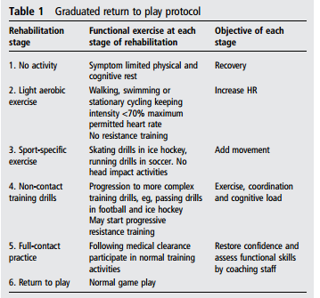

McCrory P, Meeuwisse WH, Aubry M, et al. Consensus statement on concussion in sport: the 4th International Conference on Concussion in Sport head in Zurick, November 2012. Br J Sport Med 2013 47:250-258

