- Date of Echocardiography: mm/dd/yyyy
- Echo manufacturer:
- Echo model:
- Parasternal short axis view analysis
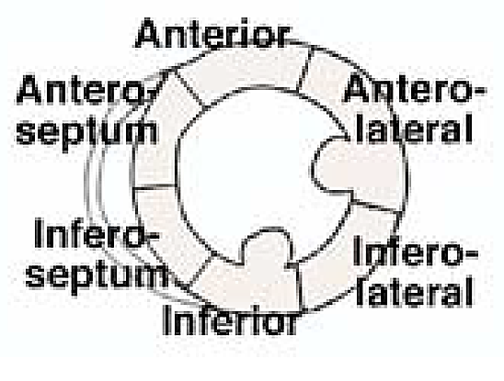
Ventricle | Anterior | Antero-lateral | Infero-lateral | Inferior | Infero-septal | Antero-septal
- Circumferential strain | Data to be entered by site | Data to be entered by site | Data to be entered by site | Data to be entered by site | Data to be entered by site | Data to be entered by site
- Radial strain | Data to be entered by site | Data to be entered by site | Data to be entered by site | Data to be entered by site | Data to be entered by site | Data to be entered by site

- 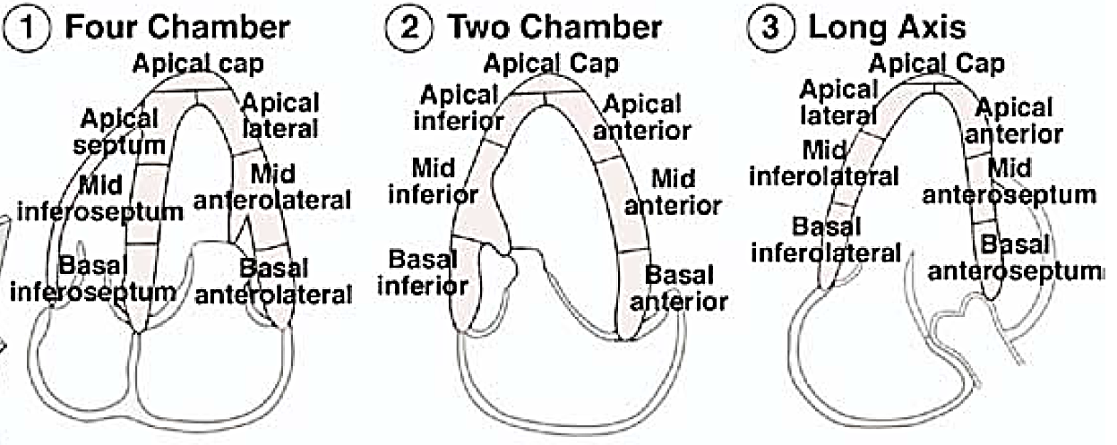Apical view analyses
Global strain
Four chamber view | Two chamber view | Long axis view (three chamber)
Data to be entered by site | Data to be entered by site | Data to be entered by site
Segmental strain—four-chamber view
Basal inferoseptum | Mid inferoseptum | Apical septum | Basal anterolateral | Mid anterolateral | Apical lateral
Data to be entered by site | Data to be entered by site | Data to be entered by site | Data to be entered by site | Data to be entered by site | Data to be entered by site
Segmental strain—two-chamber view
Basal inferior | Mid inferior | Apical inferior | Basal anterior | Mid anterior | Apical anterior
Data to be entered by site | Data to be entered by site | Data to be entered by site | Data to be entered by site | Data to be entered by site | Data to be entered by site
Segmental strain—long axis view (three chamber)
Basal inferolateral | Mid inferolateral | Apical lateral | Basal anteroseptum | Mid anteroseptum | Apical anterior
Data to be entered by site | Data to be entered by site | Data to be entered by site | Data to be entered by site | Data to be entered by site | Data to be entered by site

General Instructions
This form contains data elements that are collected to measure myocardial segmental and global contractility.

Specific Instructions
Frame rates between 40 to 80 frames/sec are generally recommended, however higher frame rates are advisable to avoid undersampling in tachycardia.
The focus should be positioned at an intermediate depth to optimize the images for 2D STE, and sector depth and width should be adjusted to include as little as possible outside the region of interest.
Any artifact that resembles speckle patterns will influence the quality of speckle tracking, and thus care should be taken to avoid these.
For software packages that process single beats, data sampling should start 100 msec before the peak R wave of the first QRS complex and end 200 msec after the last QRS to allow correct identification of the QRS complex, because failure to do so may result in erroneous drift compensation.
Apical foreshortening seriously affects the results of 2D STE, and should therefore be minimized.
The short-axis cuts of the left ventricle should be circular shaped to assess the deformation in the anatomically correct circumferential and radial directions.

Reference
Mor-Avi V, Lang RM, Badano LP, et al. Current and evolving echocardiographic techniques for the quantitative evaluation of cardiac mechanics: ASE/EAE consensus statement on methodology and indications endorsed by the Japanese Society of Echocardiography. J Am Soc Echocardiogr. 2011;24:277-313.

