Introduction
Optical coherence tomography (OCT) studies in LHON re-defined quantitatively the changes that characterize the preclinical (Savini et al., Ophthalmology 2005;112:127-31), acute and chronic stages (Barboni et al., Ophthalmology 2005;112:120-6) of the disease. These OCT studies also described the dynamic events characterizing the natural history of disease conversion from unaffected mutation carrier to affected (Barboni et al., Ophthalmology 2010;117:623-7). Furthermore, optic nerve head (ONH) analysis suggested that a larger optic disc is a protective factor in carrier and in patients who recover vision (Ramos et al IOVS 2009;50:1666).
Similarly, OCT studies has led to define the concept that patients with DOA have a congenital lower amount of axons and smaller optic discs (Milea et al, Acta Ophthalmol 2010;88:342, Barboni et al Ophthalmology 2010;117:1547), that the rate of progression (loss of fibers) parallels that of age-dependent thinning of RNFL (Barboni et al Ophthalmology 2011;118:2076) and finally that the earliest event is loss of macular RGCs, followed by thinning of the RNFL, progressing from the papillomacular bundle to the remaining quadrants (Ronnback at al Ophthalmology 2013;120:2672, Barboni et al AJO 2014). All these studies support the usefulness of a series of standardized exams based on OCT to monitor mitochondrial optic neuropathies.

Assessment of macular and optic nerve thickness
Available platforms: Cirrus, Optoview and Spectralis

These machines do not produce comparable data and the same platform should be used to standardize data collection.

Macular cube (512x128) – centered on the fovea
Available platforms: Cirrus and Optoview

Cirrus provides a measurement of the macular retinal ganglion cell and inner plexiform layer (GC-IPL) thickness (Figure 1), whereas Optoview provides measurement of the ganglion cell complex (GCC+RNFL) (Figure 2). The thickness measurements (µm) are provided as an average and as 6 individual sectors.

Optic disc cube (200x200) – centered on the optic disc
Available platforms: Cirrus, Optoview and Spectralis

For the measurement of peripapillary retinal nerve fibre layer thickness and optic nerve parameters, including (i) average RNFL thickness (µm), (ii) temporal, superior, nasal, and inferior quadrants RNFL thickness, (iii) individual clock hours RNFL thickness, (Cirrus, Optoview and Spectralis) (Figures 2-4) (iv) optic disc area (mm²), (v) optic cup volume (mm³), (vi) rim area (mm²), and (vii) average cup to disc ratio (Cirrus and Optoview) (Figures 2,3).

Assessment of retinal structure at the macula
Available platforms: Cirrus, Optoview, and Spectralis

Vertical and horizontal 6mm HD Raster lines centered on the fovea are recommended to identify inner nuclear layer (INL) cysts.

Platform: Spectralis (Figure 5)
The Spectralis Fast Macula scans are volume scans and the following parameters are frequently used: (i) 20 degree x 20 degree, (ii) 512 A-scan, and (iii) Automatic Real Time (ART) between 9 and 16. Higher ART (≥ 50) provides higher resolution images but take longer to acquire.

Platform: Cirrus and Optoview (Figure 6)
HD Raster collapsed to a single line. Depending on the extent of the lesions you are trying to image, the length (3mm, 6mm and 9mm are available) and orientation of the line can be altered.

Methods
Retinal nerve fiber layer (RNFL) thickness and GC-IPL thickness are measured by SD-OCT.
Scans are acquired using the Optic Disc Cube 200x200 and the Macular Cube 512x128 protocols in eyes with pupil dilation. After the patient had been properly seated and aligned, the iris is brought into view using the mouse-driven alignment system and the fundus image is focused.

In order to acquire the Optic Disc Cube, the ONH is centered on the live image before the centering and enhancement are optimized. The ONH parameters reported result from a fully automatic algorithm that defines both the optic disc and cup margins within the three-dimensional data cube. The disc margin is defined as the termination of Bruch’s membrane (also referred to as “neural canal opening” or “Bruch’s membrane opening”).

In order to acquire the Macular Cube, the patient is asked to fixate on the central target. The Ganglion Cell Analysis (GCA) algorithm of the Cirrus platform detects and measures the thickness of the macular GC-IPL within a 14.13-mm² elliptical annulus area centered on the fovea. The GCA algorithm processes data from 3-dimensional volume scans and measures the thickness of the macular ganglion cell-inner plexiform layer (GC-IPL). The average, minimum, and six sectoral (superotemporal (ST), superior (S), superonasal (SN), inferonasal (IN), inferior (I), inferotemporal (IT) GC-IPL thicknesses were measured from the elliptical annulus centered on the fovea (Figure 1).

Data Collection
- The study proformas need to be designed carefully, preferably in consultation with an experienced reading centre, to ensure a uniform protocol for data collection across multiple centres.
- Adequate training for the technicians performing the OCT measurements and ongoing quality control are also essential.
- The OCT signal strength should be ≥ 7, without RNFL discontinuity or misalignment, involuntary saccade or blinking artifacts, and absence of algorithm segmentation failure on careful visual inspection.

Figure 1

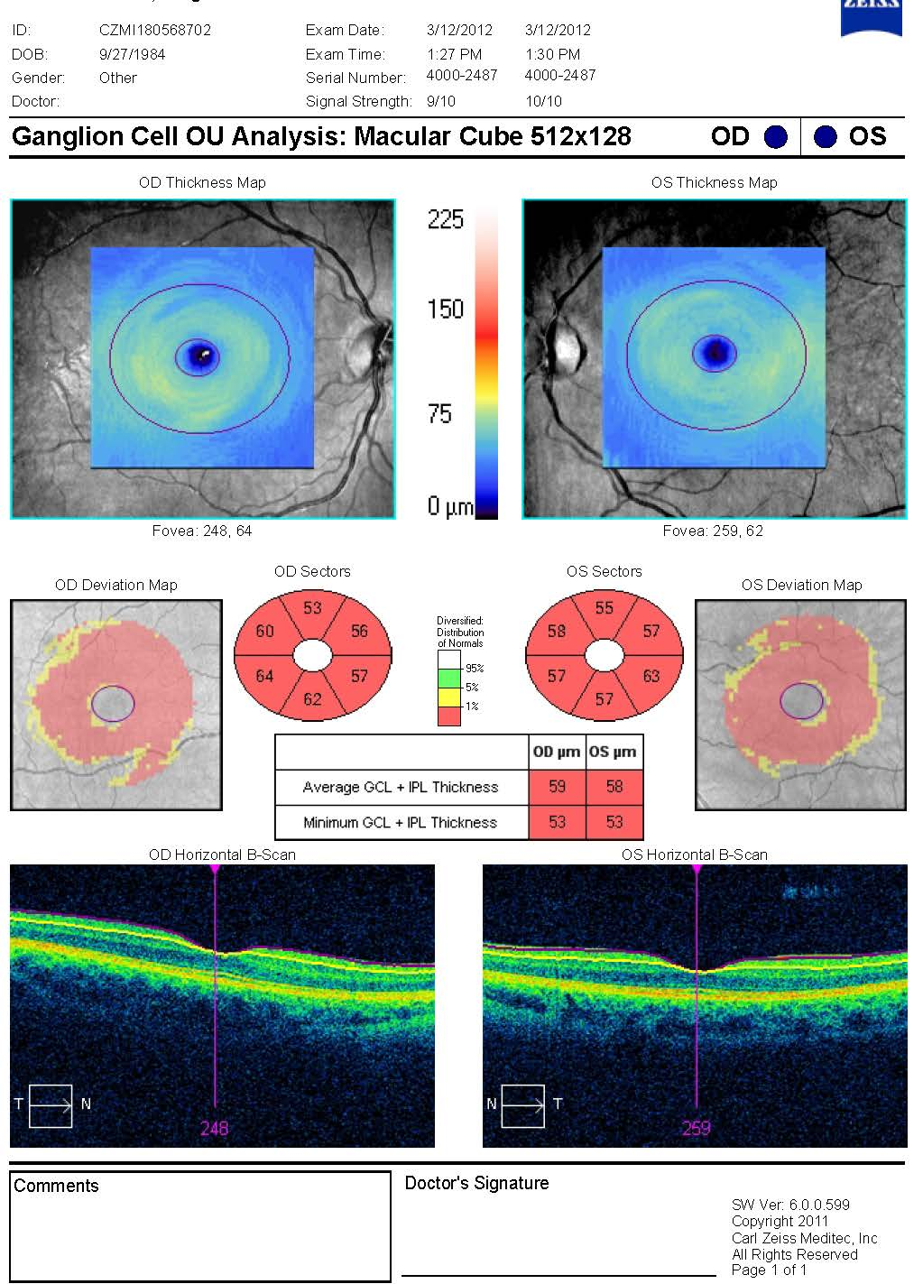
Figure 2

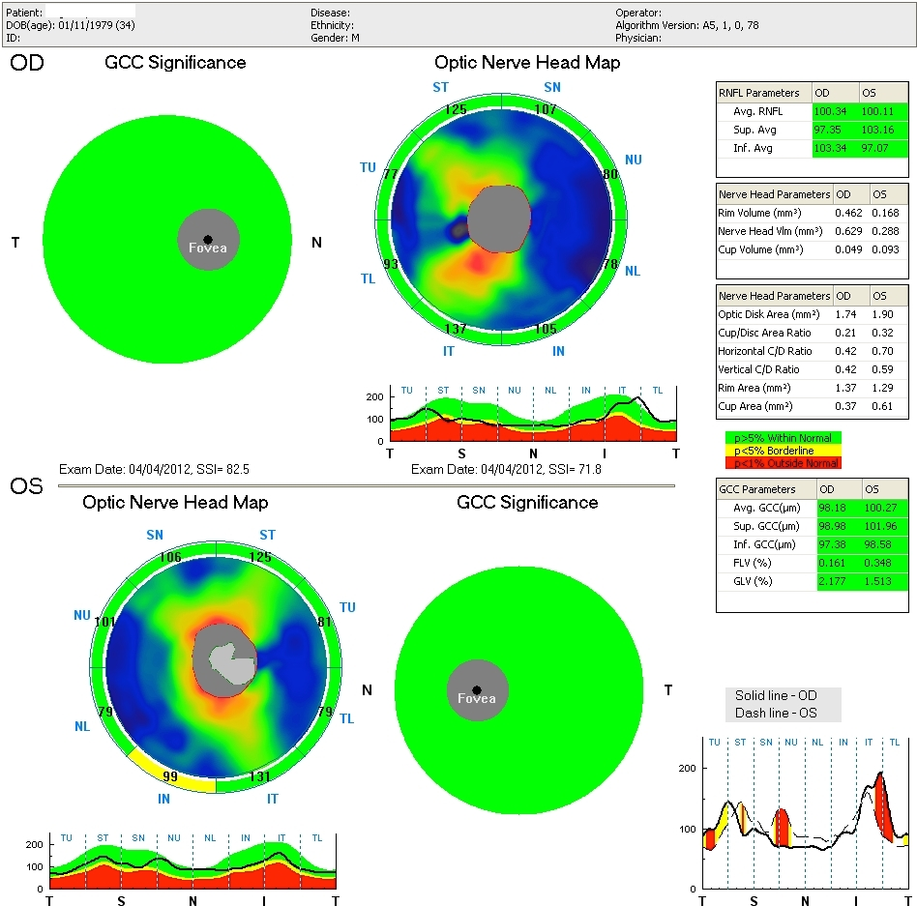
Figure 3

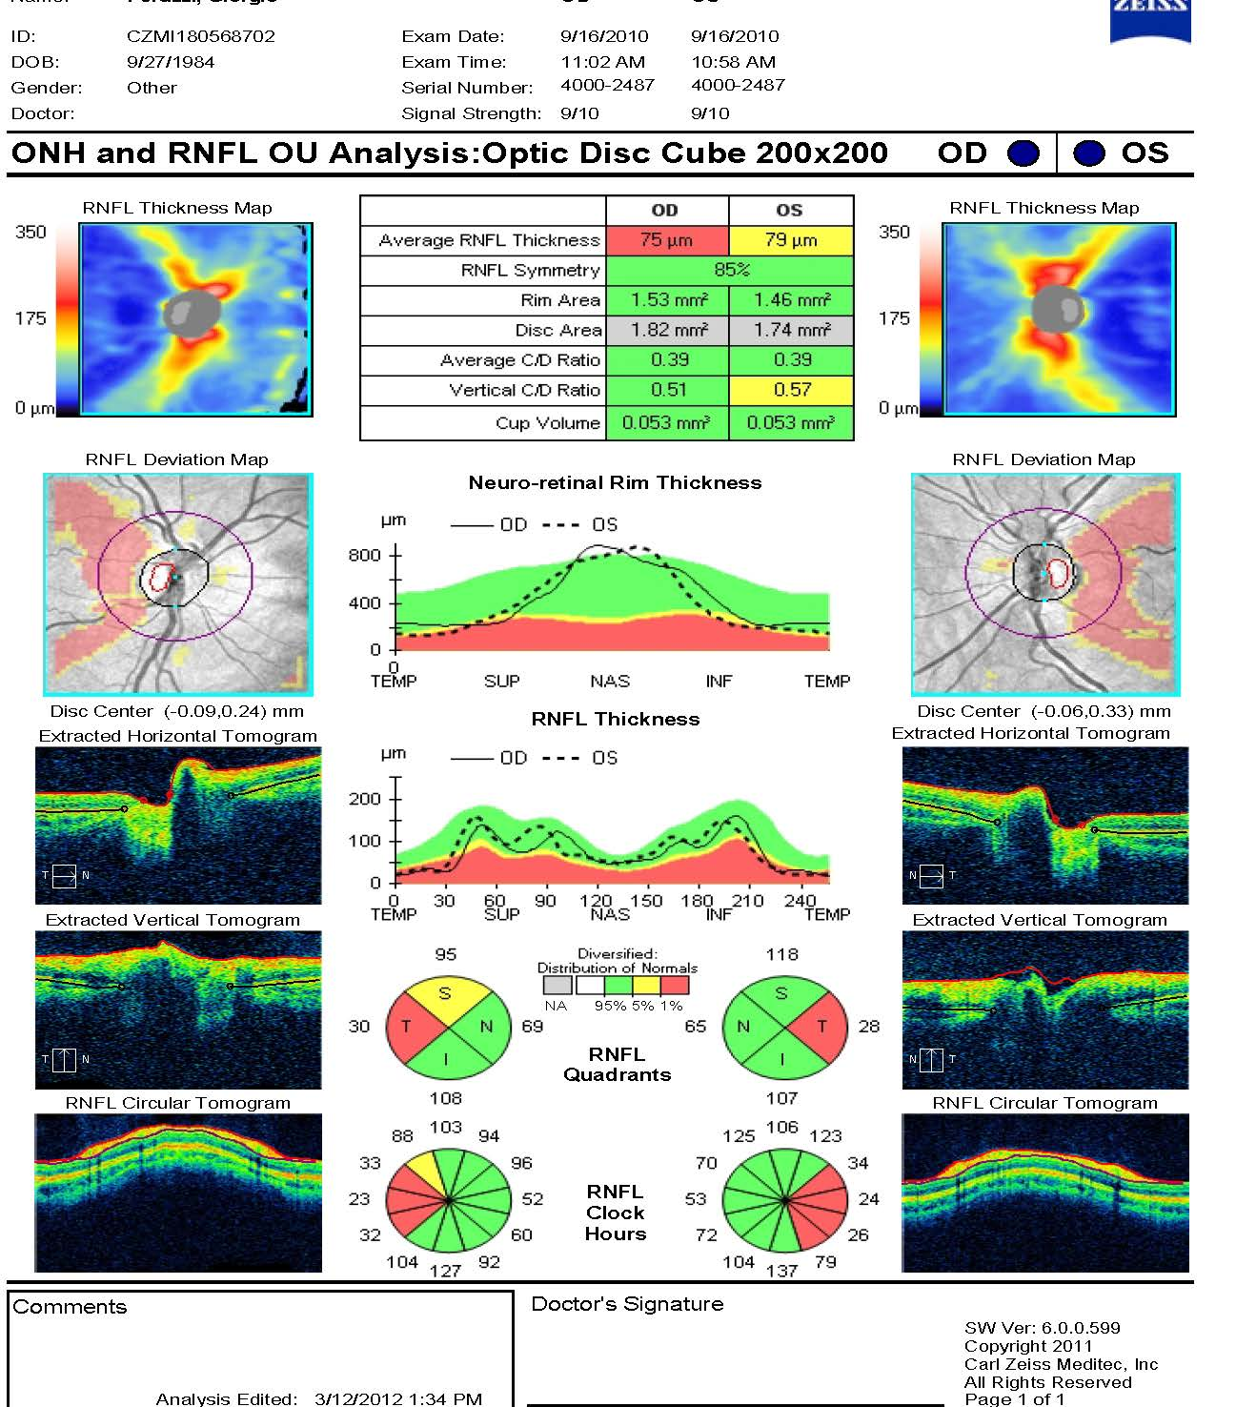
Figure 4
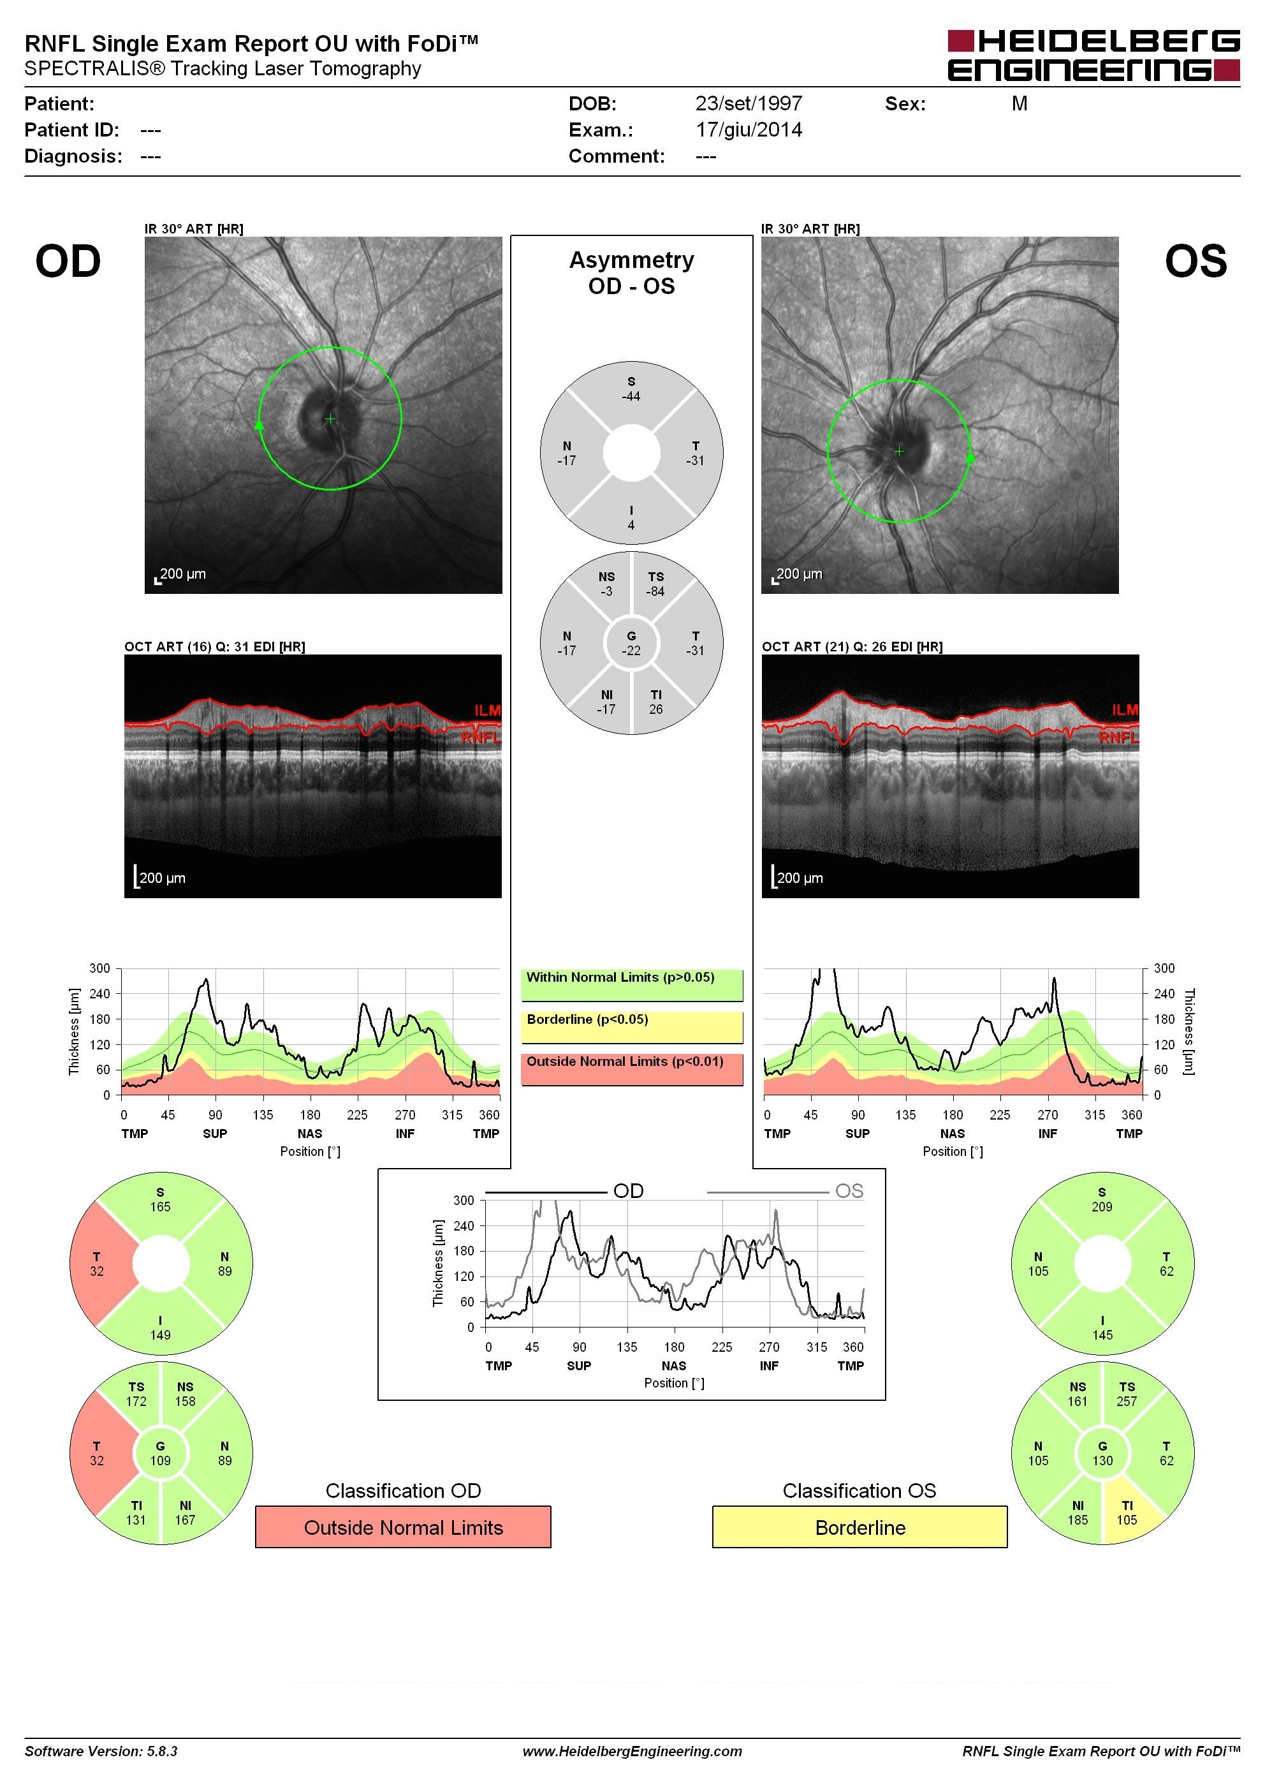

Figure 5
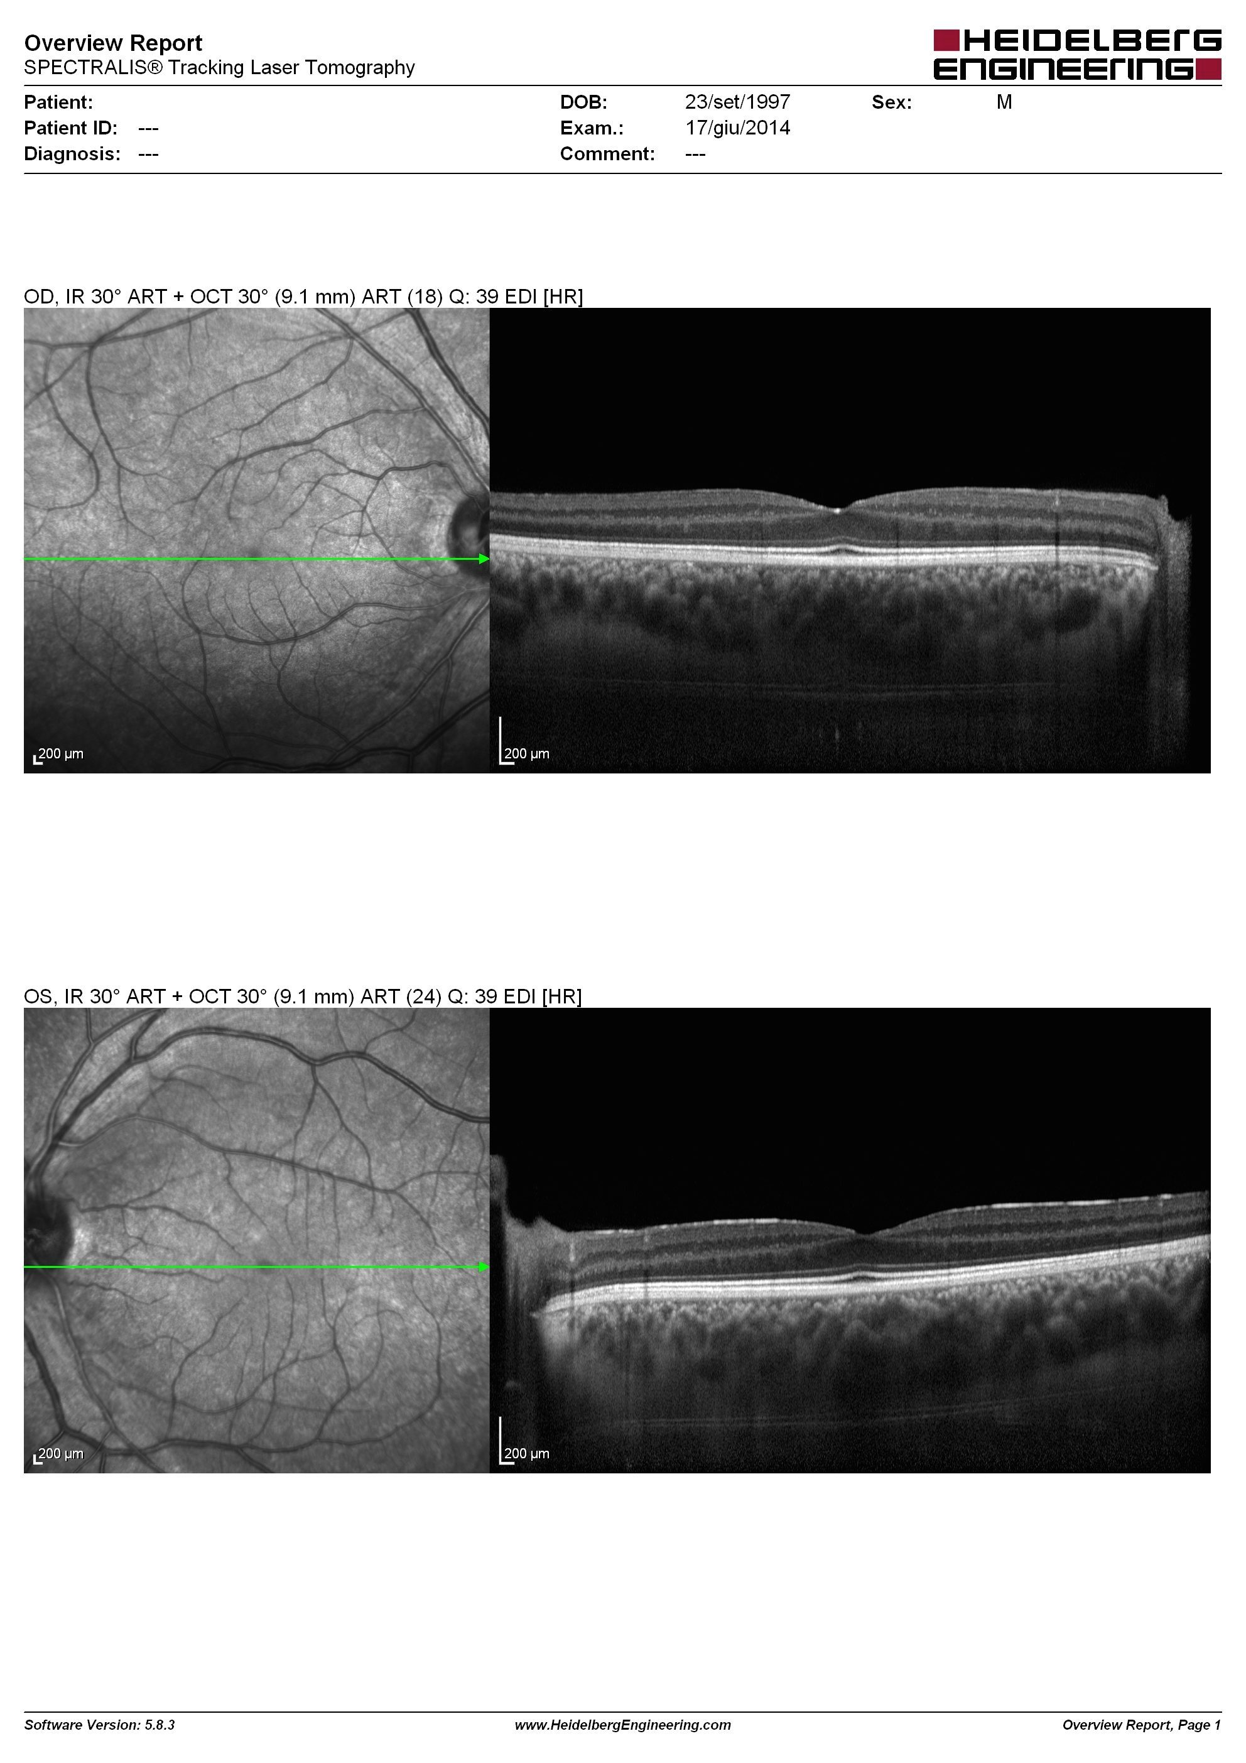
Figure 6
