Table 1 Electrical Perceptual Threshold
Dermatome | Left/Right | 1st EPT | 2nd EPT | 3rd EPT | Average of three EPTs | Comment
Add rows as needed | L | TBD | TBD | TBD | TBD | TBD
 | R | TBD | TBD | TBD | TBD | TBD
TBD: To be determined

Figure 1 Electrical Perceptual Threshold
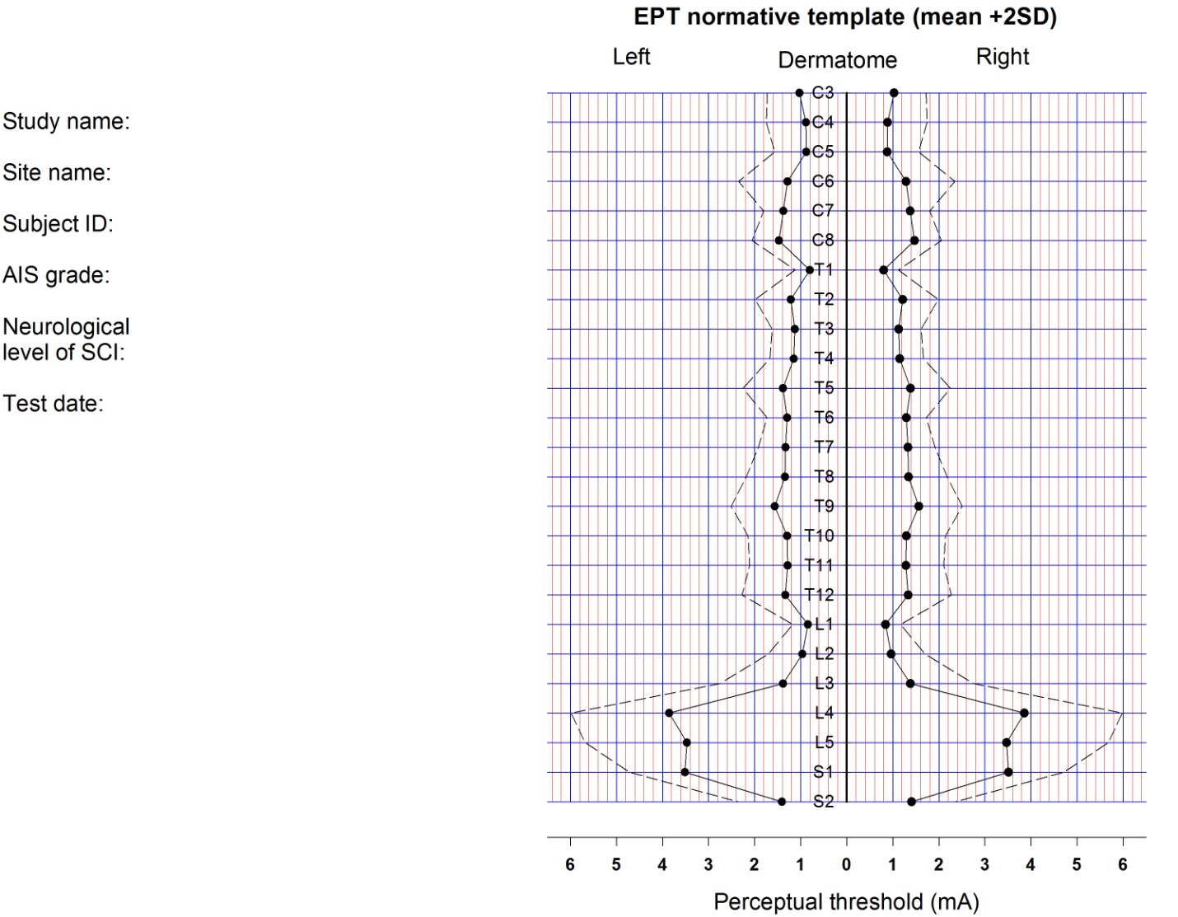

Electrical Perceptual Threshold (EPT) CRF Module Instructions

General Instructions
Important note: None of the data elements on this CRF Module are classified as Core (i.e., required for all SCI studies). The remaining data elements are classified as Supplemental or Exploratory (i.e., non Core) and should only be collected if the research team considers them appropriate for their study.
SCI-Pediatric Specific Instructions

The data elements on this CRF module are recommended as Exploratory because they require verbal responses from the person being tested so not appropriate for all age groups. The elements have not been widely used clinically. In general these tests should only be performed when there is clinical cause, not as part of studies.

Specific Instructions
Please see the Data Dictionary for definitions for each of the data elements included in this CRF Module.
- Electrical Perceptual Threshold (EPT) – Record the results of this cutaneous perception applied to all relevant, individual dermatomes. Guideline: Record EPT, left and right, for the three dermatomes immediately above the neurological level of spinal cord injury, at the level of injury and for the three dermatomes immediately below the level of injury. Include other dermatomes as directed.

