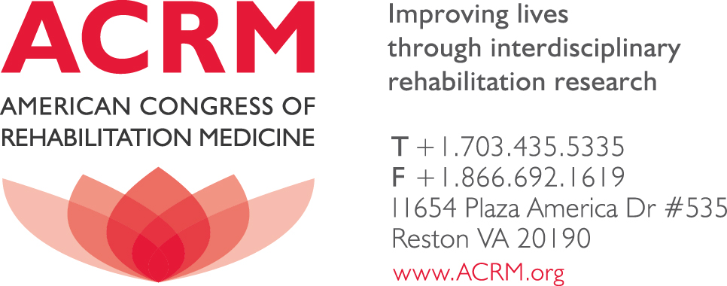

27 September, 2013

To Whom It May Concern:

The ACRM is pleased to endorse Version 2.0 of the Traumatic Brain Injury (TBI) Common Data Elements (CDEs) based on the manuscript "Progress in Developing Common Data Elements for Traumatic Brain Injury Research: Version 2 – The End of the Beginning" authored by Ramona Hicks, Joseph Giacino, Cynthia Harrison-Felix, Geoffrey Manley, Alex Valadka, and Elisabeth A. Wilde, which will be published in the Journal of Neurotrauma. The article addresses the specifics of Version 2.0 and serves as the primary reference. The TBI CDEs were developed to promote data sharing and collaboration through the standardization of data definitions and collection protocols in order to accelerate TBI research because of the enormous and growing worldwide health burden of this disorder. ACRM endorses Version 2.0 of the TBI CDEs for this purpose.

Thank you,
Tamara Bushnik, PhD, FACRM
Director of Research
Dept. Rehabilitation Medicine
Rusk Institute for Rehabilitation
240 East 38th Street, 17th Floor, 17-48
New York, NY 10016
212.263.6547
212.263.2683 (fax)
tamara.bushnik@nyumc.org
President 2011-2013
