SUBJECT ID:
- Data Source:
- Gender: Male Female Unknown Unspecified
- CAG repeat HD-IT15 CAG repeat expansion: (please specify) Not Known
- Date of Death // (m m/dd/yyyy): Time of Death : (hh:mm)
- Date of Harvesting: // (mm/dd/yyyy): Time of Harvesting : (hh:mm)
- Neuropath ID: (please specify)
- Date form completed: // (m m/dd/yyyy)

FINAL CLINICAL DIAGNOSIS BEFORE DEATH:
Huntington disease with genetically confirmed expansion of HD-IT15 CAG repeats
Huntington disease without genetically confirmed expansion of HD-IT15 CAG repeats
Huntington disease-like 2 genetically confirmed expansion of trinucleotide repeats
Huntington disease-like without genetically confirmed expansion of trinucleotide repeats
Corticobasal degeneration
Dentato-rubro-pallido-luysian atrophy (DRPLA), with genetically confirmed expansion of CAG repeats
Dentato-rubro-pallido-luysian atrophy (DRPLA), without genetically confirmed expansion of CAG repeats
Fragile X syndrome with genetically confirmed expansion of CGG repeats
Fragile X syndrome without genetically confirmed expansion of CGG repeats
Friedreich ataxia with genetically confirmed expansion of GAA repeats
Friedreich ataxia without genetically confirmed expansion of GAA repeats
Frontotemporal lobar degeneration
Hepatolenticular degeneration or Wilson disease
Kennedy disease with genetically confirmed expansion of CAG repeats
Kennedy disease without genetically confirmed expansion of CAG repeats
Multiple system atrophy
Neuroacanthocytosis
Pantothenate kinase-associated neurodegeneration (Hallervorden-Spatz syndrome)
Pick disease
Progressive supranuclear palsy
Senile or vascular chorea
Spinocerebellar ataxia with genetically confirmed expansion of either CAG or CTG repeats
Spinocerebellar ataxia without genetically confirmed expansion of either CAG or CTG repeats
Subacute sclerosing panencephalitis
Sydenham chorea
Tardive dyskinesia
Chorea gravidarum
Other (specify):
- Date of final clinical diagnosis: // (m m/dd/yyyy)

BRAIN TISSUE AND POSTMORTEM CEREBROSPINAL FLUID (CSF):
- Is banked frozen brain tissue available?
Yes No
- Is formalin-fixed brain tissue available?
Yes No
- Are paraffin-embedded blocks of brain tissue available?
Yes No
- Is banked postmortem CSF available?
Yes No
- Are other banked postmortem specimens available? (e.g., blood, spinal cord, nerve, muscle)
Yes (Describe) No
- Are macroscopic photographs available?
Yes (Describe) No
NEUROPATHOLOGICAL EXAMINATION
- Indicate the parts selected for the evaluations
Recording Parts for Evaluation Table
Macroscopical examination–Fresh | Macroscopical examination–Fixed | Macroscopical examination–Note | Microscopical examination–Source of blocks | Microscopical examination–Note
Whole brain | Whole brain | Data to be entered by site | Bilateral | Data to be entered by site
Left half brain | Left half brain | Data to be entered by site | Left half brain | Data to be entered by site
Right half brain | Right half brain | Data to be entered by site | Right half brain | Data to be entered by site
Not available (NA) | Not available (NA) | Data to be entered by site | Not available (NA) | Data to be entered by site
Other (specify): | Other (specify): | Data to be entered by site | Other (specify): | Data to be entered by site
- Brain weight–Part weighed (grams)
Table for Recording Brain/Part Weighed
Fresh Whole brain | Fresh Left half | Fresh Right half | Fresh Not available | Fixed Whole brain | Fixed Left half | Fixed Right half | Fixed Not available | Other
Data to be entered by site | Data to be entered by site | Data to be entered by site | Data to be entered by site | Data to be entered by site | Data to be entered by site | Data to be entered by site | Data to be entered by site | Data to be entered by site
- On gross examination of the external surface of the brain, cerebral atrophy:
Present Absent
If Present (Yes):
Table for Recording Cerebral Atrophy
Frontal (F) | Parietal (P) | Temporal (T) | Occipital (O)
0 | 0 | 0 | 0
1+ | 1+ | 1+ | 1+
2+ | 2+ | 2+ | 2+
3+ | 3+ | 3+ | 3+
4+ | 4+ | 4+ | 4+
Coronal Sections: The cerebral hemisphere is sectioned in the coronal plane, the brainstem is sectioned in the transverse plane, and the cerebellum is sectioned in the sagittal plane, each at intervals of 0.3–0.5 cm.
- Coronal Slices: On gross examination of the coronal sections
  - Cerebral cortex atrophy:
Present Absent
If Present (Yes):
Table for Recording Cerebral Cortex Atrophy
Frontal (F)2 | Parietal (P) | Temporal (T) | Occipital (O)
0 | 0 | 0 | 0
1+ | 1+ | 1+ | 1+
2+ | 2+ | 2+ | 2+
3+ | 3+ | 3+ | 3+
4+ | 4+ | 4+ | 4+
  - Cerebral white matter atrophy:
Present Absent
If Present:
Table for Recording Cerebral White Matter Atrophy
Frontal (F)2 | Parietal (P) | Temporal (T) | Occipital (O)
0 | 0 | 0 | 0
1+ | 1+ | 1+ | 1+
2+ | 2+ | 2+ | 2+
3+ | 3+ | 3+ | 3+
4+ | 4+ | 4+ | 4+
  - Hippocampal formation atrophy:
Present Absent
If Present
Mild 1+ Moderate 2+ Severe 3+ Very severe 4+
  - Amygdala atrophy:
Present Absent
If Present
Mild 1+ Moderate 2+ Severe 3+ Very severe 4+
- Striatum (Caudate nucleus [CN], putamen, globus pallidus, and nucleus accumbens) atrophy:
Present Absent
  - Striatum atrophy:
    - Head of the CN: At the level where the anterior limb of the internal capsule (ALIC) joins with the basal white matter: atrophy
Mild 1+ Moderate 2+ Severe 3+ Very severe 4+
    - Body of the CN: At the coronal section passing through the lateral geniculate body: atrophy
Mild 1+ Moderate 2+ Severe 3+ Very severe 4+
    - Putamen: Atrophy
Mild 1+ Moderate 2+ Severe 3+ Very severe 4+
    - Globus pallidus:
      - External segment: atrophy
Mild 1+ Moderate 2+ Severe 3+ Very severe 4+
      - Internal segment: atrophy
Mild 1+ Moderate 2+ Severe 3+ Very severe 4+
    - Status cribrosus or lacunaris, or both
If Present
Mild 1+ Moderate 2+ Severe 3+ Very severe 4+
  - Claustrum atrophy:
Present Absent
If Present
Mild 1+ Moderate 2+ Severe 3+ Very severe 4+
  - Hypothalamus atrophy:
Present Absent
If Present
Mild 1+ Moderate 2+ Severe 3+ Very severe 4+
  - Thalamus atrophy:
Present Absent
If Present
Mild 1+ Moderate 2+ Severe 3+ Very severe 4+
  - Subthalamic nucleus atrophy:
Present Absent
If Present
Mild 1+ Moderate 2+ Severe 3+ Very severe 4+
  - Red nucleus atrophy:
Present Absent
If Present
Mild 1+ Moderate 2+ Severe 3+ Very severe 4+
  - Hydrocephalus
    - Lateral ventricle

None
Mild
Moderate
Severe
Not assessed
Not available

    - Third ventricle
None
Mild
Moderate
Severe
Not assessed
Not available

    - Fourth ventricle

None
Mild
Moderate
Severe
Not assessed
Not available

  - Substantia nigra:
- Well pigmented
Darker 1+ Darker 2+ Darker 3+ Very severe 4+
Paler 1+ Paler 2+ Paler 3+ Very severe 4+
  - Nucleus coeruleus
- Well pigmented
Darker 1+ Darker 2+ Darker 3+ Very severe 4+
Paler 1+ Paler 2+ Paler 3+ Very severe 4+
  - Brainstem atrophy:
Present Absent
If Present
Mild 1+ Moderate 2+ Severe 3+ Very severe 4+
  - Cerebellum atrophy:
Present Absent
If Present
Mild 1+ Moderate 2+ Severe 3+ Very severe 4+
MICROSCOPIC EXAMINATION
- Cerebral cortex
  - Neuronal loss
Yes, neuronal loss No neuronal loss
If Neuronal loss (Yes):
Table for Recording Cerebral Cortex – Neuronal Loss
Frontal (F)2 | Parietal (P) | Temporal (T) | Occipital (O) | Other-specify
0 | 0 | 0 | 0 | Data to be entered
1+ | 1+ | 1+ | 1+ | Data to be entered
2+ | 2+ | 2+ | 2+ | Data to be entered
3+ | 3+ | 3+ | 3+ | Data to be entered
4+ | 4+ | 4+ | 4+ | Data to be entered
  - Cortical neuronal nuclear inclusions – dystrophic neuritis
Present Absent Not Available (NA)
If Present:
Table for Recording Cerebral Cortex – Cortical Neuronal Nuclear Inclusions – Dystrophic Neuritis
Frontal (F)2 | Parietal (P) | Temporal (T) | Occipital (O) | Other-specify
0 | 0 | 0 | 0 | Data to be entered
1+ | 1+ | 1+ | 1+ | Data to be entered
2+ | 2+ | 2+ | 2+ | Data to be entered
3+ | 3+ | 3+ | 3+ | Data to be entered
4+ | 4+ | 4+ | 4+ | Data to be entered
- Hippocampal formation
  - Neuronal loss
Yes, neuronal loss No neuronal loss
If Neuronal loss (Yes):
Mild 1+ Moderate 2+ Severe 3+ Very severe 4+
- Amygdala
  - Neuronal loss
Yes, neuronal loss No neuronal loss
If Neuronal loss (Yes):
Mild 1+ Moderate 2+ Severe 3+ Very severe 4+
- Is there evidence of neuronal loss and fibrillary astrocytosis? (Caudate nucleus [CN], putamen, globus pallidus and nucleus accumbens)
Table for Recording Neuronal Loss and Fibrillary Astrocytosis for Caudate Nucleus
Caudate nucleus | Neuronal loss | Fibrillary astrocytosis
Head, rostral, medial half | 0 1+ 2+  3+ 4+ NA* | 0 1+ 2+  3+ 4+ NA*
Head, rostral, lateral half | 0 1+ 2+  3+ 4+ NA* | 0 1+ 2+  3+ 4+ NA*
Head, caudal | 0 1+ 2+  3+ 4+ NA* | 0 1+ 2+  3+ 4+ NA*
Body | 0 1+ 2+  3+ 4+ NA* | 0 1+ 2+  3+ 4+ NA*
Tail | 0 1+ 2+  3+ 4+ NA* | 0 1+ 2+  3+ 4+ NA*
Table for Recording Neuronal Loss and Fibrillary Astrocytosis for Pontes Griseum or Gray Matter Caudo-Lenticular Bridges
Pontes griseum or gray matter caudo-lenticular bridges | Neuronal loss | Fibrillary astrocytosis
Dorsal half | 0 1+ 2+  3+ 4+ NA* | 0 1+ 2+  3+ 4+ NA*
Ventral half | 0 1+ 2+  3+ 4+ NA* | 0 1+ 2+  3+ 4+ NA*
Table for Recording Neuronal Loss and Fibrillary Astrocytosis for Putamen
Putamen | Neuronal loss | Fibrillary astrocytosis
Rostral, dorsal half | 0 1+ 2+  3+ 4+ NA* | 0 1+ 2+  3+ 4+ NA*
Rostral, ventral half | 0 1+ 2+  3+ 4+ NA* | 0 1+ 2+  3+ 4+ NA*
Nucleus accumbens | 0 1+ 2+  3+ 4+ NA* | 0 1+ 2+  3+ 4+ NA*
Table for Recording Neuronal Loss and Fibrillary Astrocytosis for Globus Pallidus
Globus pallidus | Neuronal loss | Fibrillary astrocytosis
Lateral | 0 1+ 2+  3+ 4+ NA* | 0 1+ 2+  3+ 4+ NA*
Medial | 0 1+ 2+  3+ 4+ NA* | 0 1+ 2+  3+ 4+ NA*
*NA: Not available
- Thalamus: Neuronal loss
Yes, neuronal loss No neuronal loss
If Yes, neuronal loss specify nuclei that are mainly involved:
If Neuronal loss (Yes):
Mild 1+ Moderate 2+ Severe 3+ Very severe 4+
Table for Recording Nuclei that are Mainly Involved
Motor nuclei Ventral anterior | Motor nuclei Ventral lateral | Centrum medianum | Limbic nuclei Anterior | Limbic nuclei Dorso-median | Other specify
0 | 0 | 0 | 0 | 0 | Data to be entered
1+ | 1+ | 1+ | 1+ | 1+ | Data to be entered
2+ | 2+ | 2+ | 2+ | 2+ | Data to be entered
3+ | 3+ | 3+ | 3+ | 3+ | Data to be entered
4+ | 4+ | 4+ | 4+ | 4+ | Data to be entered
- Subthalamic nucleus: Neuronal loss
Yes, neuronal loss No neuronal loss
If Neuronal loss (Yes):
Mild 1+ Moderate 2+ Severe 3+ Very severe 4+
- Red nucleus: Neuronal loss
Yes, neuronal loss No neuronal loss
If Neuronal loss (Yes):
Mild 1+ Moderate 2+ Severe 3+ Very severe 4+
- Cerebral white matter: Myelin loss
Yes, myelin loss No myelin loss
If Myelin loss (Yes):
Table for Recording Myelin Loss
Frontal (F)2 | Parietal (P) | Temporal (T) | Occipital (O) | Other-specify
0 | 0 | 0 | 0 | Data to be entered by site
1+ | 1+ | 1+ | 1+ | Data to be entered by site
2+ | 2+ | 2+ | 2+ | Data to be entered by site
3+ | 3+ | 3+ | 3+ | Data to be entered by site
4+ | 4+ | 4+ | 4+ | Data to be entered by site
- Substantia nigra
  - Pars compacta: Neuronal loss
Yes, neuronal loss No neuronal loss
If Neuronal loss (Yes):
Mild 1+ Moderate 2+ Severe 3+ Very severe 4+
  - Pars reticulata: Neuronal loss
Yes, neuronal loss No neuronal loss
If Neuronal loss (Yes):
Mild 1+ Moderate 2+ Severe 3+ Very severe 4+
  - Lewy body-containing neurons (LBCN) and Lewy neurites (LN)
Present Absent
If Present
Mild 1+ Moderate 2+ Severe 3+ Very severe 4+
- Nucleus coeruleus
Yes, neuronal loss No neuronal loss
If Neuronal loss (Yes):
Mild 1+ Moderate 2+ Severe 3+ Very severe 4+
  - Lewy body-containing neurons (LBCN) and Lewy neurites (LN)
Present Absent
If Present
Mild 1+ Moderate 2+ Severe 3+ Very severe 4+
  - Globosum neuronal tangles (GNT)
Present Absent
If Present
Mild 1+ Moderate 2+ Severe 3+ Very severe 4+
- Pons: Neuronal loss
Yes, neuronal loss No neuronal loss
If Neuronal loss (Yes):
Mild 1+ Moderate 2+ Severe 3+ Very severe 4+
  - Pontine nuclei: Globosum neuronal tangles (GNT)
Present Absent
If Present
Mild 1+ Moderate 2+ Severe 3+ Very severe 4+
- Medulla oblongata
  - Dorsal nucleus of vagus–reticular formation: Lewy body-containing neurons (LBCN) and Lewy neurites (LN)
Present Absent
If Present
Mild 1+ Moderate 2+ Severe 3+ Very severe 4+
  - Inferior olivary nucleus
Yes, neuronal loss No neuronal loss
If Neuronal loss (Yes):
Mild 1+ Moderate 2+ Severe 3+ Very severe 4+
- Cerebellum
  - Cortical neuronal loss
    - Associative layer (molecular)
Yes, neuronal loss No neuronal loss
If Neuronal loss (Yes):
Mild 1+ Moderate 2+ Severe 3+ Very severe 4+
    - Receptive layer (granular)
Yes, neuronal loss No neuronal loss
If Neuronal loss (Yes):
Mild 1+ Moderate 2+ Severe 3+ Very severe 4+
    - Effective layer (Purkinje cells)
Yes, neuronal loss No neuronal loss
If Neuronal loss (Yes):
Mild 1+ Moderate 2+ Severe 3+ Very severe 4+
    - Bergman gliosis (BG)
Present Absent
  - Cerebellar white matter: Myelin loss
Yes, myelin loss No myelin loss
Mild 1+ Moderate 2+ Severe 3+ Very severe 4+
  - Dentate nucleus: Neuronal loss
Yes, neuronal loss No neuronal loss
If Neuronal loss (Yes):
Mild 1+ Moderate 2+ Severe 3+ Very severe 4+

ALZHEIMER TYPE CHANGES
(e.g. Neurofibrillary tangles of Alzheimer [NTA], neuritic plaques [NP])
- NIA/Reagan Institute neuropathological criteria
Likelihood of dementia being due to Alzheimer disease (AD)
Low Intermediate High Criteria not met Not assessed Not Available
- CERAD neuropathological criteria (e.g., neuritic plaques)
Alzheimer disease (AD)
Possible Probable High Criteria not met Not assessed Not Available
- Braak & Braak Neurofibrillary Tangle Stage
Absent Present Not assessed Not Available
If yes (Present), select Braak stage
Stage I Stage II Stage III Stage IV Stage V Stage VI
- Staining methods used for neurofibrillary tangles of Alzheimer
  - Immunohistochemistry:
    - Antibodies:
  - Silver methods
1 = Bielschowsky
2 = Other, specify:
3 = Not assessed
4 = Missing/unknown
- Staining methods used for amyloid plaques
  - Immunohistochemistry:
    - Antibodies:
  - Silver methods
1 = Bielschowsky
2 = Other, specify:
3 = Not assessed
4 = Missing/unknown
- Staining methods used for Lewy Bodies
- Immunohistochemistry:
    - Antibodies:
- Silver methods
1 = Bielschowsky
2 = Other, specify:
3 = Not assessed
4 = Missing/unknown
- Amyloid plaques
- Neuritic plaques (plaques with amyloid core surrounded by a halo with dystrophic neurites)

No neuritic plaques
Sparse (up to 2 per 100x field)
Moderate (up to 6 per 100x field)
Frequent (>7 per 100X field)
Not assessed
Unknown

- Immature and diffuse type plaques (are plaques without the dense core of the neuritic plaques and are either with [immature] or without [diffuse] dystrophic neurites)

No neuritic plaques
Sparse
Moderate
Frequent
Not assessed
Unknown

ISCHEMIC, HEMORRHAGIC OR VASCULAR CHANGES
- Are there ischemic, or hemorrhagic changes?
Yes, Present (complete table below) No (skip to Q2) Not assessed Unknown
Table for Recording Vascular territories (ACA: anterior cerebral artery; MCA: middle cerebral artery; PCA: posterior cerebral artery)
Intentionally Left Blank | ACA | MCA | PCA | Combined
Single | Data to be entered by site | Data to be entered by site | Data to be entered by site | Data to be entered by site
Multiple | Data to be entered by site | Data to be entered by site | Data to be entered by site | Data to be entered by site
- Are there single, or multiple cortical microinfarcts (each, <1.5cm in greatest dimension, including “granular atrophy”)?
Yes (complete table below) No Not assessed Unknown
Table for Recording Vascular territories (ACA: anterior cerebral artery; MCA: middle cerebral artery; PCA: posterior cerebral artery)
Intentionally Left Blank | ACA | MCA | PCA | Combined
Single | Data to be entered by site | Data to be entered by site | Data to be entered by site | Data to be entered by site
Multiple | Data to be entered by site | Data to be entered by site | Data to be entered by site | Data to be entered by site
- Are there single, or multiple lacunes (each > 1.5cm, but ≥2cm small artery infarcts)?
Yes (complete table below) No Not assessed Unknown
Table for Recording Vascular territories (ACA: anterior cerebral artery; MCA: middle cerebral artery; PCA: posterior cerebral artery)
Intentionally Left Blank | ACA | MCA | PCA | Combined
Single | Data to be entered by site | Data to be entered by site | Data to be entered by site | Data to be entered by site
Multiple | Data to be entered by site | Data to be entered by site | Data to be entered by site | Data to be entered by site
- Are there single, or multiple hemorrhages?
Yes (complete table below) No Not assessed Unknown
Table for Recording Vascular territories (ACA: anterior cerebral artery; MCA: middle cerebral artery; PCA: posterior cerebral artery)
Intentionally Left Blank | ACA | MCA | PCA | Combined
Single | Data to be entered by site | Data to be entered by site | Data to be entered by site | Data to be entered by site
Multiple | Data to be entered by site | Data to be entered by site | Data to be entered by site | Data to be entered by site
- Is there cortical laminar necrosis?
Yes (complete table below) No Not assessed Unknown
Table for Recording Vascular territories (ACA: anterior cerebral artery; MCA: middle cerebral artery; PCA: posterior cerebral artery)
Intentionally Left Blank | ACA | MCA | PCA | Combined
Single | Data to be entered by site | Data to be entered by site | Data to be entered by site | Data to be entered by site
Multiple | Data to be entered by site | Data to be entered by site | Data to be entered by site | Data to be entered by site
- Are there other vascular-depending changes, which were not previously specified?
Yes, specify other:
No, not found Not assessed Unknown
- Are there atherosclerotic, either non-stenotic or stenotic vascular changes (of the circle of Willis)?
Yes, non-stenotic None Not assessed Unknown
Yes, stenotic (estimated luminal stenosis in percent)

Mid 1+ (up to 30% stenosis)
Moderate 2+ (up to 50% stenosis)
Severe 3+ (up to 80% stenosis)
Very severe 4+ (apparent occlusion)

- Is there arteriosclerosis (small parenchymal arteriolar disease)?
Yes No Not assessed Unknown
If yes
Mild 1+ Moderate 2+ Severe 3+ Very severe 4+
- Is cerebral amyloid angiopathy present?
Yes Not found: No Not assessed Unknown
If yes: Congo red -amyloid
“Grade 1” “Grade 2” “Grade 3” “Grade 4”
Grade 0: Denotes the absence of amyloid (evidenced either with Congo red, or with -amyloid antibodies)
Grade 1: Some amyloid deposits are found in an otherwise normal appearing vessel
Grade 2: Complete replacement of the media by amyloid
Grade 3: Refers to cracking of the amyloid-laden vessel wall (creating a vessel-within-vessel appearance affecting at least 50% of the circumference of the vessel)
Grade 4: Denotes the presence in an amyloid-laden vessel of fibrinoid necrosis recognized as homogeneous discrete foci or segments of the wall, which contain smudgy eosinophilic material obscuring the cytoarchitecture
Stroke 1997; 28:1418-1422.

CONCOMITANT MAIN DIAGNOSIS
Yes No Not assessed Unknown
If yes
1.
2.
3.
4.
5.

FINAL CLINICOPATHOLOGICAL DIAGNOSIS (ES)
Table for Recording Final Clinicopathological Diagnosis (ES)
Huntington disease | Grade 1 | Grade 2 | Grade 3 | Grade 4
Encephalopathy of hypoxic-ischemic type, acute | Mild | Moderate | Severe | Data to be entered by site
Alzheimer changes | Mild | Moderate | Severe | Data to be entered by site
Status cribrosus and lacunaris | Mild | Moderate | Severe | Data to be entered by site
There is no diagnostic abnormality recognized
Control brain Huntington disease, grade O
If without neurological and psychiatric troubles, and without HD-IT15 CAG repeat expansion
If without neurological and psychiatric troubles, but with HD-IT15 CAG repeat expansion
The National Institute on Aging-Alzheimer's Association published in November 2011 guidelines for scoring the Alzheimer changes on postmortem examination. According to these guidelines, an “ABC” score is assigned, which encompasses the CERAD score, and the modified Braak & Braak stage. If the “ABC” scheme is applied, please consider providing the respective scores:
A: parenchymal amyloid burden or deposits A1 A2 A3
B: Based on Braak stage for neurofibrillary tangles B1 B2 B3
C: Based on CERAD score for neuritic plaques C1 C2 C3
Montine TJ, Phelps CH, Beach TG, et al. National Institute on Aging-Alzheimer's Association guidelines for the neuropathologic assessment of Alzheimer's disease: a practical approach. Acta Neuropathologica 2011;123:1-11.

General Instructions
This CRF contains data that would be collected when a neuropathology study is performed to study disease of nervous system tissue and how it relates to Huntington disease.
Important note: None of the data elements included on this CRF Module are classified as Core (i.e., strongly recommended for Huntington disease clinical studies to collect if imaging studies are performed). All data elements are classified as supplemental (i.e., non Core) and should only be collected if the research team considers them appropriate for their study. Please see the Data Dictionary for element classifications.

Specific Instructions
Please see the Data Dictionary for definitions for each of the data elements included in this CRF Module.
Microscopic Examinations:
The brunt of the neuropathologic changes in HD involves the striatum with the occurrence of widespread neuronal nuclear ubiquitinated inclusion and dystrophic neurites. Recommended techniques for the microscopical evaluation are:
- Laboratory with limited means (without opportunity to perform immunohistochemistry)––
Sections stained with Hematoxylin and eosin (HE) or Luxol fast blue counterstained with hematoxylin and eosin (LHE) for general survey; Bielschowsky for assessing neurofibrillary tangles of Alzheimer, neuropil threads, and neuritic plaques; and Congo red especially for assessing amyloid-laden vessels.
- Recommended antibodies for immunohistochemistry––
- Ubiquitin for neuronal nuclear inclusions and dystrophic neuritis
- AT8 for detection of hyperphosphorylated tau (NTA, neuropil threads, Pick bodies, glial cytoplasmic inclusions)
- Beta-amyloid for parenchymal (immature, diffuse, and neuritic type plaques), and vascular amyloid burden (CAA)
- Alpha-synuclein for Lewy body-containing neurons, Lewy neurites, glial cytoplasmic inclusions (multiple system atrophy)
Amyloid Plaques: Neuritic plaques- plaques with argyrophilic dystrophic neurites, and with, or without dense amyloid cores [assessed in the most affected area of the slide]
The CRF includes all instructions available for current data elements in Version 1.0. More detailed instructions will be added in Version 2.0 of this CRF Module.

References and Additional Information
Experience indicates that the neuropathological changes occurring in brains from patients with Huntington disease (HD) are consistent in nature, but variable in severity, which in turn, to some extent, determines the spreads of the changes especially beyond the striatum.
The assessment of the neuropathological changes depends on the methods applied to evaluate the brains. This proposal is constructed with the assumption that the methods chosen are the ones used conventionally within a clinical setting.
Carriers of the HD-IT15 mutation (greater than or equal to 36 CAG repeats) usually have a shorter life expectancy than non-carriers, which reduces the probability of multiple pathological changes, related to usual aging or old age.
- “Pure” HD brains
Neuropathological severity of HD, grading system
The severity of the neuropathological changes observed at the postmortem examination of the HD brains is mainly driven by the age onset, the age when death occurs and by the length of the CAG repeats. Thus, the spectrum is wide, but well characterized. Grading the severity is, therefore, an issue to consider. However it might be unreasonable to request pathologists or neuropathologists not familiar with HD to assign a grade. Indeed, the opportunity to evaluate HD brains is very rare, except within dedicated centers. Nonetheless, assigning a grade is important for brains that are samples for research.
The distribution of the grades that were assigned to two series of HD brains (an old series [OS], n = 382 brains; a recent series [RS], n = 93 brains – see below) is provided to help address this issue.
The neuropathological grading system was developed with a framework of distinctive, temporospatial pattern of degeneration in the HD striatum. The assignment of a grade of neuropathological severity is based on gross and microscopical findings using conventional methods of examination that include the striatum: (1) at the level of the nucleus accumbens; (2) the caudal edge of the anterior commissure; and (3) at the level of the lateral geniculate body. This system has five grades (0 – 4) of severity of striatal involvement. This grading system applies to brains from individuals diagnosed clinically as having HD, with or without genetic test confirmation.
Grade 0 (< 1 percent of HD brains): Gross examination shows features indistinguishable from normal brains. On general survey using LHE- or HE-stained slides, neither reactive gliosis nor neuronal loss is reliably detectable. However, further evaluations including cell counts indicate a 30 – 40 percent loss of neurons in the head of the caudate nucleus (HCN), and no visible reactive astrocytosis. Ubiquitinated neuronal inclusions may occur long before the occurrence of symptoms in brains from carriers of the HD-IT15 CAG repeat expansion (Gómez-Tortosa et al. Annals of Neurology 2001;49:29-34).
Grade 1 (about 4 percent): The tail of the caudate nucleus (TCN) is much smaller than normal, and atrophy of the body of the caudate nucleus (BCN) may also be noticeable. Neuronal loss and astrogliosis involve the TCN, and less so the BCN, the dorsal portion of both the head and nearby putamen.
NB: The TCN of neurologically normal subjects may show variations including periodic constrictions or segmentations. In contrast to HD, the variations occasionally detected in normal brains are focal, and, therefore, likely to be apparent in only one or two coronal sections.
Grade 2 (about 16 percent): Gross striatal atrophy is mild to moderate in grade 2 (the medial outline of the HCN is only slightly convex but still bulges into the lateral ventricle)
Grade 3 (about 52 percent): The striatal atrophy is severe (the medial outline of the HCN forms a straight line or is slightly concave medially). The microscopic changes in grades 2 and 3 are more severe than in grade 1, and less than in grade 4 brains.
Grade 4 (28 percent of all HD brains; but about 100% of HD brains from patients with juvenile onset of symptoms): The striatum is severely atrophic (the medial contour of the HCN is concave, as is the anterior limb of internal capsule. The neostriatum has lost 95 percent or more neurons. In at least 50 percent of grade 4 brains, the nucleus accumbens remains relatively preserved.
Details on the grading system can be found in Journal of Neuropathology and Experimental Neurology 1998;57:369-384.
NB: “Pure” HD brains might in addition have substantial changes consistent with acute hypoxic-ischemic events, often terminal.
Neostriatal, relatively preserved islets (Revue Neurologique 1992;148:107-16.)
A subset of HD brains displays discrete islets that are relatively preserved compared to the surrounding parenchyma. These islets tend to occur within the rostral neostriatum, and perhaps are more common in individuals with long CAG repeats. The occurrence of such changes is rare (> 3 percent of postmortem HD brains: OS: n = 18 of 382; RS: n = 5 of 93), and might not justify having it addressed in the NP data form.
- Associated changes: Usual aging–or concomitant diseases
To determine the main items pertaining to HD, selected information was extracted from two series of HD brains that were evaluated according to the same protocol. For the older series ([OS] 1991 – 2000; n = 382) immunohistochemistry was not applied. For the more recent series ([RS] 2004 – 2010; n = 93), immunoperoxidase was applied. The blocks obtained for microscopical examination were identical for both series.
The mean age at death can be informative for the selection of the changes because the increase of the frequency and scope of changes is proportional to the longevity. The age at death is known for 348 or the 382 patients of the old series.
Mean age at death:
OS n = 348: 60 years (max 96, min 16 years)
RS n = 93: 57 years (max 83, min 8 years)
The relative frequency of selected changes occurring in usual aging is provided below only for the RS.
The selected changes encompass the loads of neuritic plaques, neurofibrillary tangles of Alzheimer [NTA] with related scores based on all of these: Consortium to Establish a Registry for Alzheimer’s Disease [CERAD], Braak stage for NTA, Lewy body-containing neurons [LBCN] with the neuropathologic stage of Parkinson disease related changes.
  - Concomitant Alzheimer disease (AD):
Apparently, HD patients over the age of 60 have the same probability to develop AD as individuals without the HD mutation.
Among the 382 OS patients, 15 had changes in their brain the severity of which met the diagnosis of AD, in addition of the HD changes (mean age 77 years [max 90, min 59])
Among the 93 RS patients, 2 had neuropathological changes of AD in addition to the HD changes (78, 61 years respectively).
The 17 patients with AD had HD-IT15 CAG repeat expansion.
  - Concomitant amyotrophic lateral sclerosis (ALS):
OS: n = 3 (mean age 52 years)
RS: n = 1 (65 year old).
Old series (OS): Huntington disease: n = 382 brains
Mean age at death: 60 years (minimum 16, maximum 96)
Standardized neuropathological examination (without immunohistochemistry)
Graphic Showing Neuropathological Grades - 1
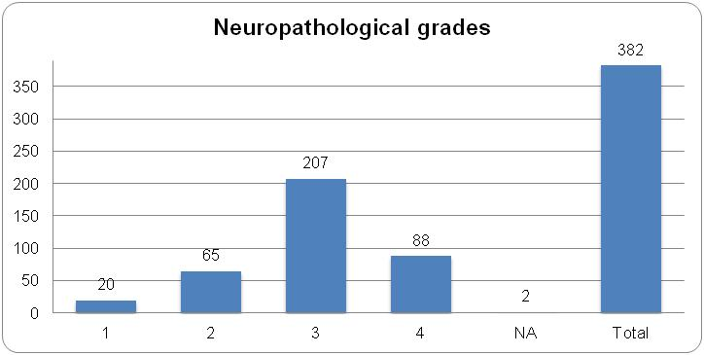
NA: Not available.
Recent series (RS): Huntington disease: n = 93 brains
Mean age at death: 57 years (minimum 8, maximum 83)
Standardized neuropathological examination with immunoperoxidase techniques
Graphic Showing Neuropathological Grades - 2
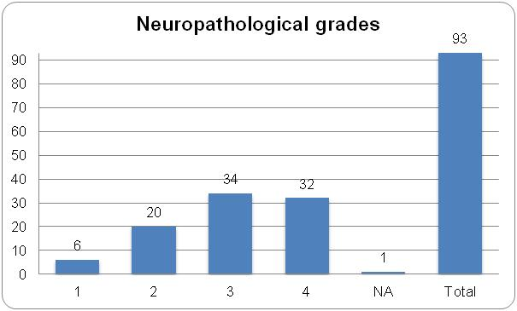
NA: Not available.
–Vonsattel, J-P, Myers, RH, Stevens, TJ, Ferrante, RJ, Bird, ED, Richardson, EP, Jr. Neuropathological classification of Huntington’s disease. J Neuropathol Exp Neurol 1985;44:559-577.
–Vonsattel, J.-P. G. and M. DiFiglia. “Huntington disease.” Journal of Neuropathology and Experimental Neurology 1998;57:369-384.
Huntington disease: n = 93 brains
Mean age at death: 57 years (minimum 8, maximum 83)
- Neuritic plaques–Consortium to Establish a Registry for Alzheimer’s Disease (CERAD)
CERAD scores assigned to 86 of the 93 HD brains
Graphic Showing CERAD - Neuritic Plaques
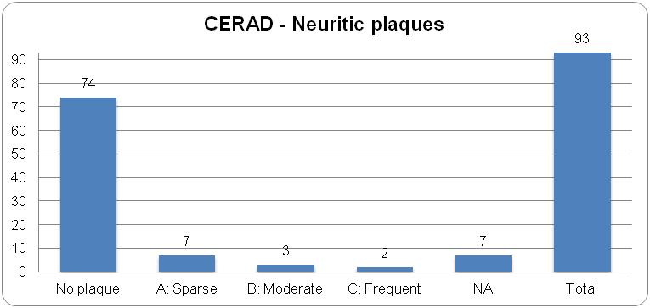
NA: Not available.
Number of neuritic plaques (Bielschowsky) per 100X microscopic field within the most affected area of the slide:
Sparse: up to two
Moderate: up to six
Frequent: up to 33
–Mirra SS, Heyman A, McKeel D, et al. The Consortium to Establish a Registry for Alzheimer’s Disease (CERAD). Part II. Standardization of the neuropathologic assessment of Alzheimer’s disease. Neurology. 1991;41:479-486.
Huntington disease: n = 93 brains
Mean age at death: 57 years (minimum 8, maximum 83)
- Neurofibrillary tangles of Alzheimer (NTA)
Frequency of the occurrence and Braak stage of NTA assigned to 86 of the 93 HD brains
Graphic Showing Neurofribrillary Tangles
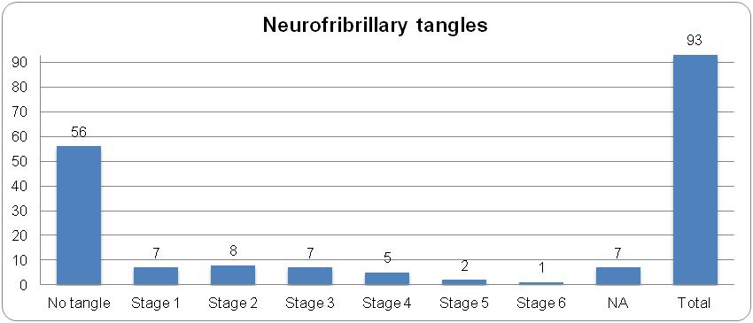
NA: Not available.
The stage of the neurofibrillary tangles of Alzheimer is assigned according to the criteria by Braak et al.
–Braak H, Braak E, Bohl J. Staging of Alzheimer related cortical destruction. European Neurology 1993;33:403-408.
–Braak H, Alafuzoff I, Arzberger T, Kretzschmar H, Del Tredici K. Staging of Alzheimer disease-associated neurofibrillary pathology using paraffin sections and immunocytochemistry. Acta Neuropathologica 2006;112:389-404.
Huntington disease: n = 93 brains
Mean age at death: 57 years (minimum 8, maximum 83)
- Determination of the likelihood that dementia is due to Alzheimer disease lesions
Scores of The National Institute on Aging, and Reagan Institute Working Group on Diagnostic Criteria for the Neuropathological Assessment of Alzheimer’s Disease assigned to 86 of the 93 HD brains
Graphic Showing NIA - RIWG
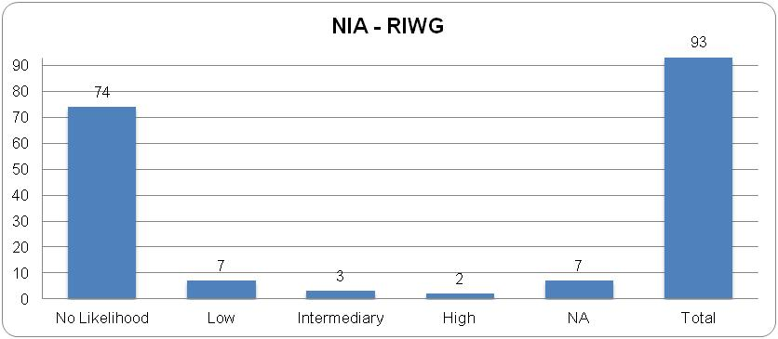
NA: Not available.
There is a high likelihood that dementia is due to AD lesions when the postmortem brain shows the presence of both NP & NT in neocortical (i.e., a frequent NP score according to CERAD, & a stage 5, or 6, of 6, according to Braak & Braak.
There is an intermediate likelihood that dementia is due to AD lesions when the postmortem brain shows moderate neocortical NP & NT in limbic regions (i.e., CERAD moderate, & Braak &Braak stage 3, or 4, of 6).
There is a low likelihood that dementia is due to AD lesions when the postmortem brain shows NP & NT in a more limited distribution, or severity, of both (i.e., CERAD infrequent, & Braak &Braak stage 1, or 2, of 6) [….].
AD: Alzheimer disease; NP: neuritic plaques; NT: neurofibrillary tangles of Alzheimer; CERAD: Consortium to Establish a Registry for Alzheimer’s Disease.
–The National Institute on Aging. Consensus recommendations for the postmortem diagnosis of Alzheimer’s disease. Neurobiology of Aging 1997;18(S4):S1-S2.
Huntington disease: n = 93 brains
Mean age at death: 57 years (minimum 8, maximum 83)
- Cerebral amyloid angiopathy (CAA)
Frequency of the occurrence and grades of CAA assigned to 85 of the 93 HD brains
Graphic Showing Cerebral amyloid angiopathy (CAA)
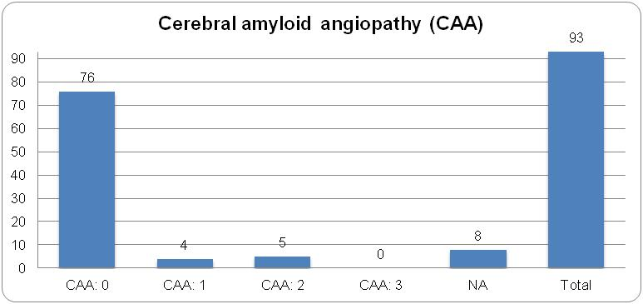
Cerebral amyloid angiopathy (CAA) NA: Not available.
Neuropathologic grades of severity of CAA:
Grade 0: Denotes the absence of amyloid within the walls of vessels.
Grade 1: Some amyloid deposits are found in an otherwise normal appearing vessels.
Grade 2: There is complete replacement of the media by amyloid.
Grade 3: Refers to cracking of the amyloid-laden vessel wall (creating a vessel-within-vessel appearance affecting at least 50% of the circumference of the vessel).
Grade 4: Denotes the presence in an amyloid-laden vessel of fibrinoid necrosis, which is recognized as homogeneous discrete foci or segments of the vascular wall, which contain smudgy eosinophilic material obscuring the cytoarchitecture […].
–Vonsattel, JP, Myers, RH, Hedley-Whyte, ET, Ropper, AH, Bird, ED, Richardson, EP, Jr. Cerebral amyloid angiopathy without and with cerebral hemorrhages: a comparative histological study. Ann Neurol 1991;30:637-649.
–Greenberg, SM, Vonsattel, J-PG. Diagnosis of cerebral amyloid angiopathy. Sensitivity and specificity of cortical biopsy. Stroke 1997;28:1418-22.
Huntington disease: n = 93 brains
Mean age at death: 57 years (minimum 8, maximum 83)
- Lewy body-containing neurons (LBCN)
Frequency of the occurrence and Braak stage of LBCN assigned to 85 of the 93 HD brains
Graphic Showing Lewy Body Containing Neurons
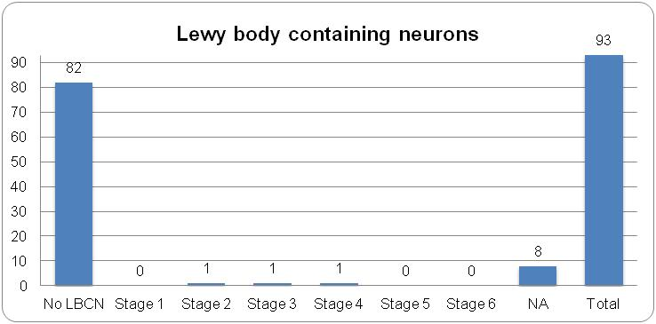
NA: Not available.
The stage of the LBCN is assigned accordig the criteria by Braak et al.
–Braak H, Del Tredici K, Rüb U, de Vos RAI, Steur ENH, Braak E. Staging of brain pathology related to sporadic Parkinson’s disease. Neurobiology of Aging 2003;24:197-211.
–Braak H, Rüb U, Steur J, Del Tredici K, de Vos RAI. Cognitive status correlates with neuropathologic stage in Parkinson disease. Neurology 2005;64:1404-10.

Frequently seen in African Americans
None = 0, Mild 1+/4+, Moderate 2+/4+, Severe = 1+/4+, Very severe 4+/4+
Very rarely encountered on postmortem examination of brains of symptomatic patients. The likelihood to make such an observation would be while evaluating the brain of an individual who war carrier of the HD-IT15 CAG repeat expansion, and who died without detectable symptom of HD.
The accumulation of neuromelanin within the neurons of the pars compacta of the substantia nigra (or nucleus coeruleus) is approximately linear from birth to age 60 years (Brain 1974; 97:489-498). On gross examination of the transverse-cut surface of the mesencephalon, the pigment of the pars compacta becomes gradually visible at the time of puberty. Therefore, depending on the age of death, the substantia nigra may appear pale in juvenile HD brains. Compared to controls, the pars compacta is darker in adult onset HD, perhaps because of the relative increase in the density of pigmented neurons secondary to the loss of neuropil. However, in rare instances, for example, when HD and Parkinson disease are concomitant the pars compacta is likely to be paler than usually expected in adult onset HD.
The gross morphological correlates of age-related with or without disease-related volume loss of the brain are narrowing of the gyri and widening of the sulci, and ventricular dilatation. Assessing the atrophy of gyri rather than that of the cortex alone improves the appraisal of the loss of volume since both the cortex and subcortical or gyral white matter tend to be involved simultaneously. In-vivo evaluation of brain atrophy using computerized tomography might be more reliable than the assessment at postmortem examination. Indeed, agonal states including cerebral edema are likely to affect the volume of the brain and, therefore, masking the actual parenchymal loss. Furthermore, precise measurements of the brain weight provide relative information. In fact, it is difficult to interpret postmortem brain weights given the normal range, thus the individual variations. The estimate of brain atrophy is, therefore, relative, and depends greatly on these variables. Kemper TL. Neuroanatomical and Neuropathological changes during aging and dementia, Second edn., Oxford University Press, New York, 1994, 3-67. Esiri MM and Morris JH. Practical approach to pathological diagnosis. In: Esiri MM, Lee VM-Y, Trojanowski JQ, eds. The neuropathology of dementia. First ed. Cambridge CB2 2RU, UK: Cambridge University Press; 2004:48-74.

