Sample Study Visit Schedule
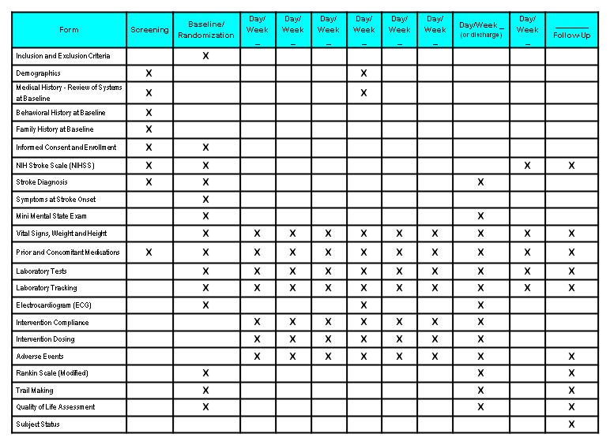

General Instructions
The Visit Schedule, also referred to as a schedule of assessments or schedule of events, is a matrix that shows when the study assessments/events are to be done, as outlined by the protocol. Typically such a matrix is included in the study protocol or at least described with text. The assessments/events are listed down the page as rows and the visits/time points are listed across the page as columns in the matrix. An 'X' indicates that the particular assessment/event is done at the specific visit/time point.

Specific Instructions
There are no specific instructions.

