Hip Joint (°) | Left Side | Right Side
Flexion
Extension
Thomas Test
Internal Rotation
External Rotation
Abduction
Adduction

Knee Joint (°) | Left Side | Right Side
Flexion
Extension
Popliteal Angle
Ely Test (+ or -)
Thigh-Foot Angle (TFA) (Note internal or external rotation)
Transmalleolar Angle (TMA)

Ankle Joint (°) | Left Side | Right Side
Dorsiflexion (knee extended)
Dorsiflexion (knee flexed)
Plantarflexion

General Instructions
None of the data elements included on this CRF Module are classified as Core (i.e., strongly recommended for all Cerebral Palsy clinical studies to collect). All data elements on this CRF Module are classified as Supplemental (i.e., non-Core) and should only be collected if the research team considers them appropriate for their study. Please see the Data Dictionary for element classifications.

Information on the movements of the hip, knee, and ankle joints of the participant. Each joint is measured in degrees (°). Ely’s test can be measured in degrees or can be denoted with (+) or
(-). When there is a contracture or limitation in range where the joint’s neutral position cannot be achieved, this should be noted with a negative (-) before the number of degrees lacking in range.

For Joint Angle, measurements are taken slowly, and the reported range of motion values represent R2 of the Tardieu Scale. For range at higher speeds that are aimed to measure the effects of spasticity, please see the Tardieu Scale.

Hip movements include flexion, extension, Thomas Test, internal rotation, external rotation, abduction, and adduction.

Knee movements include extension, flexion, Ely, popliteal angle, thigh-foot angle and transmalleolar angle.

Ankle movements include plantarflexion and dorsiflexion (knee extended and flexed).

Specific Instructions
Please see the Data Dictionary for definitions for each of the data elements included in this CRF Module.

Ely’s test or Duncan-Ely test is used to assess rectus femoris spasticity or tightness. (Marks et al., 2003)

The Thomas Test (also known as Iliacus Test or Iliopsoas Test) is used to measure the flexibility of the hip flexors, which includes the iliopsoas muscle group, the rectus femoris, pectineus, gracilis, as well as the tensor fascia latae and the sartorius. (Harvey et al., 1998)

Popliteal angle test tests whether certain knee muscles are activated and whether the position of pelvis affects the level of muscles activation. (Manikowska et al., 2019)

The thigh-foot angle (TFA) is the angular difference between the axis of the foot and thigh when the patient is in a prone position with the knees flexed 90 degrees and the foot and ankle are in neutral position. The TFA normally ranges from +10 to +15 degrees.

The transmalleolar angle (TMA) is the angle between the longitudinal axis of the thigh with a line perpendicular to the axis of the medial and lateral malleolus. Tibial rotation is measured using the TMA.

References
Harvey D. Assessment of the flexibility of elite athletes using the modified Thomas test. Br J Sports Med. 1998;32(1):68-70.

Manikowska F, Chen BP, Jóźwiak M, Lebiedowska MK. The popliteal angle tests in patients with cerebral palsy. J Pediatr Orthop B. 2019;28(4):332-336.

Marks MC, Alexander J, Sutherland DH, Chambers HG. Clinical utility of the Duncan-Ely test for rectus femoris dysfunction during the swing phase of gait. Dev Med Child Neurol. 2003;45(11):763-768.

duPont Gait Lab Range of Motion Definitions

  - PROM – Tests for the Hip (goniometer and/or angle finder)
    - Hip flexion: Position patient supine. Flex hip until pelvis begins to tilt posteriorly indicating the end of pelvic-femoral motion and the beginning of spinal motion. The line bisecting the femur relative to the horizontal pelvis indicates the degree of available hip flexion. Record the external angle to reflect the number of degrees the femur rotated through. In the photo below, the angle of hip flexion is approximately 120 degrees.

1.1.2. Hip extension: (Staheli method) Position the patient prone with legs off the edge of exam table but comfortably supported. The hips are flexed to flatten the lumbar spine. Lift the thigh to extend the hip joint. End range is indicated by the beginning of anterior pelvic tilting. The bisection of the femur is measured in relationship to the horizontal pelvis indicating range of available hip extension. Lack of extension is indicated by a minus sign. Pelvic stabilization is critical to differentiate hip motion from pelvic motion. In the photo below, the patient does not quite achieve neutral position, and therefore has approximately -5° hip extension, or lacking 5°.

1.1.3. Thomas Test: Position the patient supine with their pelvis close to the edge of the table and both hips flexed maximally. The tested thigh is lowered slowly to extend the hip joint. End range is indicated by tightness halting progression of the thigh. The bisection of the femur is measured in relationship to the horizontal pelvis indicating range of available hip extension. Lack of extension is indicated by a minus sign.

• When the hip extension range of motion is less than the range measured in prone (as above in 1.1.2), this indicates iliopsoas tightness.

1.1.4 Hip abduction: Position patient supine with both hips and knees resting in extension and neutral rotation. Keeping the knee extended and the hip in neutral rotation, abduct the hip while gently stabilizing the opposite pelvis and hip. Position the goniometer along the line connecting the right and left ASIS points with the moving arm along the midline of the femur. The available range of abduction is noted when pelvis begins to shift. In the photo example, there is approximately 30° of hip abduction on the right leg.

• Knee extension is critical to accurately assess gracilis flexibility.

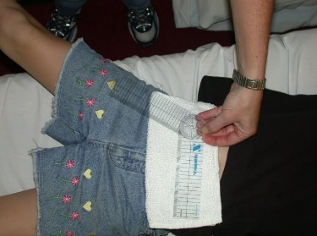

1.1.5 Hip Adduction: Position patient supine with both hips and knees resting in extension and neutral rotation. Keeping the knee extended and the hip in neutral rotation, adduct the hip while gently stabilizing the pelvis. Position the goniometer along the line connecting the right and left ASIS points with the moving arm along the midline of the femur. The available range of adduction is noted when pelvis begins to shift. In the photo example, there is approximately 20° of hip adduction on the left leg.

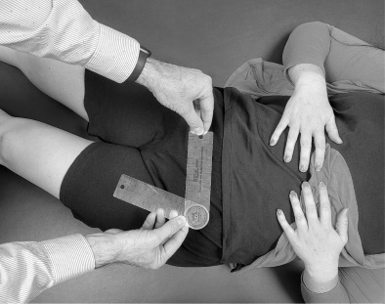

1.1.6 Hip external rotation: Position the patient prone with thighs supported on the exam table and hips resting in extension and neutral ab-adduction. Flex knee to 90º, gently stabilize the pelvis with one hand, palpating the ipsilateral greater trochanter (GT). Lower the leg medially, into external hip rotation. End range of ER is noted when resistance is felt or the ipsilateral pelvis rises, indicating the beginning of pelvic rotation. The longitudinal bisection of the tibia is measured relative to the vertical plane (The use of a plumb line can be used to confirm/mark vertical). Here the patient has approximately 50° of hip external rotation.

1.1.7 Hip internal rotation: Position the patient prone with feet off the edge of exam table and hips resting in extension and neutral ab-adduction. Flex knee to 90º, gently stabilize the pelvis with one hand, palpating the contralateral greater trochanter (GT). Lower the leg laterally, into internal hip rotation. End range of IR is noted when resistance is felt or the contralateral pelvis rises, indicating the beginning of pelvic rotation. The longitudinal bisection of the tibia is measured relative to the vertical plane. This example shows approximately 75° of hip internal rotation.

1.2 PROM - Tests for the KNEE

1.2.1 Knee flexion: Position the patient supine with legs supported in neutral. Flex hip to 90º and the further flex knee to maximum, until resistance stops motion. The angle of the tibial crest in relationship with the lateral midline bisection of the femur is measured. In the example below, there is approximately 150° knee flexion.

1.2.2 Knee extension: Position the patient supine. Place one hand under the distal tibia and then extend the knee until the point of resistance. The lateral bisection of the tib-fib is measured in relationship to the lateral bisection of the femur. Lack of full extension is noted by a (-) sign. Hyperextension is noted by documenting a range of motion. In the photo, there is 0° knee extension.

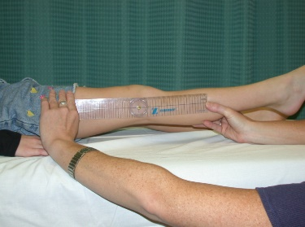

1.2.3 Popliteal angle: Position the patient supine with hip positioned in 90º of flexion. Maintain the hip in 90º of flexion while extending the knee to the point of resistance or when the opposite hip begins to rise (indicating posterior pelvic tilting). The longitudinal bisection of the tibia is measured in relationship to the longitudinal bisection of the femur. Popliteal angle is reported as the supplement to this, or the range needed to reach full knee extension; in the photo it would be approximately 60º.

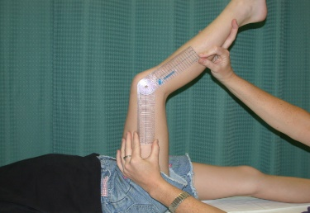

1.2.4 Tibial torsion Thigh Foot Angle (TFA): Position the patient prone with knee flexed to 90º and the ankle in neutral DF with STJ neutral position. Place the goniometer along the long axis of the plantar surface of the foot, bisecting the heel. The TFA is formed by the angle between this line and the line bisecting the posterior midline of the femur. Note internal or external rotation. In the photo, the TFA shows approximately 30° external rotation.

• Accounts for rotation at and above the level of the STJ

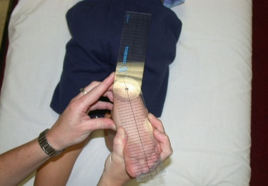

1.2.5 Ely Test: Position the patient prone, with hip extension and one hand gently stabilizing the pelvis. Slowly flex the knee until resistance is noted or when the hip begins to flex, indicating the end range of the rectus femoris. The angle of the tibial crest in relationship with the lateral midline bisection of the femur is measured.

• Difference from the supine knee flexion measure indicates rectus femoris tightness. When the knee flexion range of motion in Ely Test position (shown below) is less than that measured in supine (as above in 1.2.1), document (+) Ely Test. If they are the same range of motion, document (-).

1.3 PROM - Tests for the FOOT / ANKLE - Clarification – STJ locked in supination vs. STJ neutral

1.3.1 Ankle dorsiflexion* knee flexed: Position the patient prone with legs supported in neutral rotation. Flex the knee to 90º and palpate the talar head at the sinus tarsi and above the navicular tuberosity; position the sub-talar joint (STJ) in a fully supinated (locked) position. Grip the lateral column of the foot to maintain the STJ locked position, and DF the talocrural joint until resistance is felt and the STJ locked position cannot be maintained. The angle formed by the lateral longitudinal bisection of the fibula and the lateral plantar surface of the calcaneus is measured. This is the available ROM of the soleus, and ankle dorsiflexion with knee flexed in the photo below is 10°.

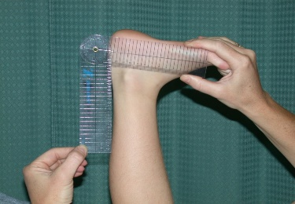

1.3.2 Ankle dorsiflexion* knee extended: Position the patient prone with legs comfortably supported in neutral rotation. Extend the knee to 0º and position the sub-talar joint (STJ) in a fully supinated (locked) position. Grip the lateral column of the foot to maintain the STJ locked position, and DF the talocrural joint until resistance is felt and the STJ locked position cannot be maintained. The angle formed by the lateral longitudinal bisection of the fibula and the lateral plantar surface of the calcaneus is measured and 90° is considered neutral. This is the available ROM of the gastrocnemius, and the ankle dorsiflexion with knee extended below is 10°.

• Use caution to avoid midfoot and forefoot motion.

1.3.3 Ankle plantarflexion: Position the patient prone with legs comfortably supported in neutral rotation. Extend the knee to 0º and position the sub-talar joint (STJ) in a fully supinated (locked) position. Grip the lateral column of the foot to maintain the STJ locked position, and PF the talocrural joint until resistance is felt in the pretibial muscles. The angle formed by the lateral longitudinal bisection of the fibula and the lateral plantar surface of the calcaneus is measured, and 90° is considered neutral. Plantarflexion shown below is approximately 50°.

• Use caution to avoid midfoot and forefoot motion.

Used with permission from the duPont Gait Lab at the Nemours/Alfred I. duPont Hospital for Children, Wilmington, DE.

