Physical Therapy Individual Session Form
General Information | Patient Name or ID#: Therapist: Date: GMFCS Level (circle): MACS Level (circle)  I II III IV V I II III IV V
Session Information | Session Duration (total time in minutes) | Units Billed (15 minute increments):
Session Type:D Individual □ Group □ Co-Tx If CoTx: □ SLP □ PT □ Other |  | Child Effort Rating: 0 1 2 3 4 5 6 (see p. 2)
Session Participants: # patients # therapists # family/caregiver |  | Pain □ Y □ N If yes, list pain level number
Setting: □ Inpatient (acute med)D Inpatient (acute rehab) □ Inpatient (subacute rehab)  - Outpatient Clinic □ Early Intervention □ School-based □ Day Tx Program □ Home-based  - Day Care □ Residential Facility □ Other Community □Other |  | Pain Scale- circle scale used: Faces FLACC Visual analog (see p. 3)
Factors influencing session:
- agitation/behavior □ disinterest □ fatigue □ low arousal
- inattention □ emotional distress/crying □ medical □environment
Frequency: per week per month consultative (< 1 x month) other

PT Focus Areas | Mins | Intervention |  |  | Devices |  | Orthoses |  | | Interventions | Modality | Equipment | Assistive tech devices
 |  |  |  |  |  |  |  |  | 01 Assessment/Evaluation | 19 Electrical stimulation  (a- NMES b-Tens) | 37 Elliptical | 56 AAC Device
Pre-Functional |  |  |  |  |  |  |  |  | 02 Education/Training |  | 38 UBE | 57 Pictures/Schedules
 |  |  |  |  |  |  |  |  | Neuromuscular | 20 Deep thermal? | 39 Seated stepper | 58 Switches
Sitting |  |  |  |  |  |  |  |  | 03 Balance | 21 Hot/cold | 40 Wall rail/furniture | 59 computer
 |  |  |  |  |  |  |  |  | 04 Postural Control | 22 Biofeedback |  | 60 Modifier
Standing |  |  |  |  |  |  |  |  | 05 Coordination | 23 Telehealth | 41 Push toy | 61 Virtual Reality
 |  |  |  |  |  |  |  |  | 06 Motor control | Integumentary | 42 Walker | 62 Video gaming
Transitions/  transfers |  |  |  |  |  |  |  |  | 07 Facilitation/handling | 24 Pressure relief | 43 Manual w/c | 63 Pet Therapy
 |  |  |  |  |  |  |  |  | 08 Repetitive task | 25 Position changes | 44 Power w/c | AQ Aquatic Therapy
Mobility
 |  |  |  |  |  |  |  |  | 09 Oral – Motor Facilitation | 26 Skin Check | 45 Gait trainer | Orthoses
Gait- household,  community,  exercise |  |  |  |  |  |  |  |  |  | 27 Energy conservation | 46 Hoyer lift | 64 AFOs
 |  |  |  |  |  |  |  |  | Musculoskeletal | AE/ orthotic | 47 Stander | 65 SMO
 |  |  |  |  |  |  |  |  | 10 Manual therapy | 28 Prescription | 48 Other AE | 66 FO
Fitness/Health/  recreation  management |  |  |  |  |  |  |  |  | 11 Joint Mobilization | 29 Fabrication | Positioning | 67 HKAFO
 |  |  |  |  |  |  |  |  | 12 Massage | 30 Maintenance/repair | 49 static seating | 68 TLSO
 |  |  |  |  |  |  |  |  | 13 Strengthening  functional | 31 Ergonomic/ universal design | 50 dynamic seating | 69 Serial casting  a) Ankle b) Knee
Self-care
 |  |  |  |  |  |  |  |  | 14 Stretching | 32 Training | 51 static standing | 70 Knee immobilizer
gross motor
 |  |  |  |  |  |  |  |  | 15 Strengthening (PRE) | 33 Fitting/Adjustment | 52 Dynamic standing | 71 Neuroprosthesis (FES)
Communication
 |  |  |  |  |  |  |  |  | Cardiopulmonary | Equipment | 53 Floor position | 72 KAFO
 |  |  |  |  |  |  |  |  | 16 Breathing | 34 BWS system | Assistive tech | 73 Elastic wraps/suits
Caregiver
management
 |  |  |  |  |  |  |  |  | 17 Aerobic conditioning | 35 Treadmill | 54 Adapted toys/games | 74 Therapeutic taping
 |  |  |  |  |  |  |  |  | 18 Postural drainage | 36 Stationary bike | 55 Electronic (tablet, PDA) | 75 Shoe insert off the shelf

Physical Therapy Individual Session Form
This case report form (CRF) contains data elements related to individual physical therapy sessions the participant/subject receives. To report data for whole episodes of rehabilitative care use the episode of care CRF.
Specific Instructions
This form was designed to be inclusive of the possible activities and interventions that therapists could use. We are not suggesting, however, that a therapist should address all of these focus areas or use all of these interventions
Focus Area: Select each appropriate focus area and record the time spent on each area with the child in 5-minute increments. Please indicate the approximate time spent in each focus area and for each round the time into 5 minute increments. To determine the focus area, you will need to identify the primary intent of each activity. If the primary emphasis is on two focus areas, then split the time between the two areas.
Interventions: Then move to the list of Interventions, Device and Orthoses to the right (numbered 01–75). Select all interventions, devices and orthoses that were performed to achieve the purpose of each selected focus area and write the code numbers of the interventions used within the boxes provided.
GMFCS Level refers to the Gross Motor Function Classification System expanded and revised which is available at www.canchild.ca MACS level refers to the Manual Abilities Classification System www.mac.nu
Child Effort Rating (adapted from Westcott-McCoy and Linn 2010, Horn 2015): record an overall rating for “Child Effort” across the entire session by circling a number on the visual analogue scale: 0 = child’s behavior during the session(s) was not at all conducive to achieving the service objectives, to 6 = child’s behavior during the session(s) was exceptionally conducive to achieving the service objectives Choose the number that best fits your initial impression.
0= absence of effort 1=minimal effort 2=below average effort 3=Average effort 4=above average effort 5=very good effort 6=superior effort
This scale should reflect the normal distribution of the population, which means that a score of 0 or 6 is uncommon. Most people tend to fall into the categories of 2, 3, and 4 where 3 would be average effort. This is not a measure of the patient’s ability! Choose the number that best fits what you observed the patient DO- not whether s/he did his/her “best”.
This form is adapted from:
Effgen S, Westcott McCoy S, Chiarello L, Jeffries L, Bush H. Physical therapy-related child outcomes in school: An example of practice-based evidence methodology. Pediatr Phys Ther. 2016;28(1):47–56.
Horn S, Corrigan J, Bogner J, Hammond F, Seel R, Smout R, Barrett R, Whiteneck G. Traumatic brain injury - practice based evidence study: Design and patients, centers treatments, and outcomes. Arch Phys Med Rehab. 2015;96(8 Suppl 3):S178–S196.
McCoy SW, Linn M. (2010). Training Manual School - Physical Therapy Interventions for Pediatrics (S-PTIP) Data Form version 4.
Specific Instructions
Pain Scales
The pain score is the fifth vital sign and a critical part of patient care. Pain should be assessed regularly, at least every eight hours, typically using of the scales appearing below (B, C, or D). Scale A, the N-PASS, is used only in specialized situations and can be obtained from the Education Department if necessary. Regardless of the scale used, pain should be assessed before and after each management intervention and the child and family should be actively involved in the process.

Scale B - (Revised) FLACC (Face, Legs, Activity Cry, Consolability)
Face | 0  No particular expression or smile | 1  Occasional grimace or frown, withdrawn, disinterested, sad, appears worried | 2  Frequent to constant quivering chin, clenched jaw, distressed looking face, expression of fright/panic
Legs | Normal position, or relaxed, usual tone & motion to limbs | Uneasy, restless, tense, occasional tremors | Kicking, or legs drawn up, marked increase in spastically, constant tremors, jerking
Activity | Lying quietly, normal position, moves easily, regular, rhythmic respirations | Squirming, shifting back and forth, tense, tense/guarded movements, mildly agitated, shallow/splinting respirations, intermittent sighs | Arched, rigid or jerking, severe agitation, head banging shivering, breath holding, gasping, severe splinting
Cry | No cry  (awake or asleep) | Moans or whimpers; occasional complaint, occasional verbal outbursts, constant grunting | Crying steadily, screams or sobs frequent complaints, repeated outbursts, constant grunting
Consolability | Content, relaxed | Reassured by occasional touching, hugging, or being talked to, distractible | Difficult to console, or comfort, pushing caregiver away, resisting care or comfort measures
The FLACC is a behavior pain assessment scale for use in non verbal patients unable to provide reports of pain. Instructions: 1. Rate patient in each of the live measurement.
2. Add Together. 3. Document total pain score.
Scale C - Faces Rating Scale (Wong Baker)
Scale D – 0–10 Numeric Pain Rating Scale
Scale C – Faces Rating Scale (Wong Baker)
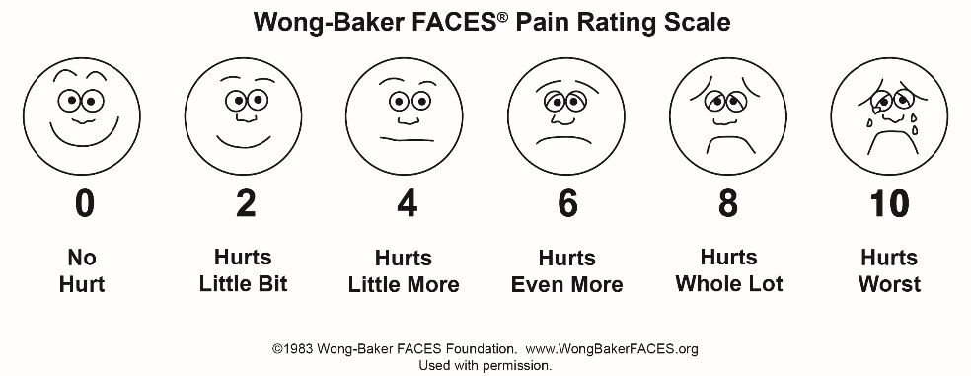

Explanation:
- For use with ages 4 and older
- Explain to the child that each face is for a person who feels happy because he has no pain (hurt), or sad because he has some or a lot of pain

Face 0 is very happy because he doesn’t hurt at all.
Face 2 hurts just a little bit
Face 4 hurts a little more
Face 6 hurts even more
Face 10 hurts as much as you can imagine

Ask the child to choose the face that best describes how he/she is feeling.
0=no pain 1–3=mild pain 4=moderate pain 7–10=severe pain

Scale D – 0–10 Numeric Pain Rating Scale

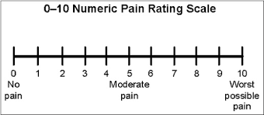

Explanation:
- For use with ages 8 and older
- Explain to the child that at one end of the line is 0, which means that a person feels no pain (hurt). At the other end is a 10, which means the person feels the worst pain imaginable. The numbers 1 to 9 are for a very little pain to a whole lot. Ask the child to choose the number that best describes how he/she is feeling.

0=no pain 1–3=mild pain 4=moderate pain 7–10=severe pain

